 

  

***Anjalai Ammal Mahalingam Engineering College***

# Department of Computer Science And Engineering

**Completed the project named as**

Laptop Request Catalog Item

**Team ID :** NM2025TMID07337

**Team Size :** 4

**Team Leader :** Ajmal Shakeel B

**Team member 1 :** Gowthamraj S

**Team member 2 :** Hamdan Mohamed K.H

**Team member 3 :** Haynesh R

 

# Abstract

The *Laptop Request Catalog Item* project aims to automate and simplify the laptop request process within an organization using ServiceNow. The previous manual system caused delays and data inaccuracies. To overcome these issues, a dynamic Service Catalog Item was developed with features such as dynamic form fields, reset functionality, and clear user guidance. UI Policies and UI Actions were implemented to enhance interactivity and accuracy, while update set management ensured smooth deployment. Testing confirmed improved efficiency, reduced errors, and a better user experience. Overall, the project streamlines laptop requests, enhancing workflow speed and employee satisfaction.

# Introduction

In modern organizations, efficient IT service management plays a vital role in ensuring smooth operations and employee productivity. One of the common challenges faced by companies is managing hardware requests, such as laptops, through manual or email- based processes. These traditional methods often lead to delays, incomplete data, and lack of tracking, affecting both IT staff and end users. To overcome these issues, an automated and user-friendly solution was needed to streamline the laptop request process.

ServiceNow was chosen as the platform for this project because it is a powerful cloud- based IT Service Management (ITSM) tool widely used by enterprises to automate workflows, manage service requests, and improve overall efficiency. Its Service Catalog feature allows organizations to create interactive request forms with dynamic behavior, ensuring accurate data collection and faster processing. Additionally, ServiceNow provides capabilities for customization, form design, workflow automation, and deployment management, making it an ideal choice for this project.

The main objectives of the *Laptop Request Catalog Item* project are:

* To automate and streamline the laptop request process.
* To create a dynamic and user-friendly Service Catalog Item.
* To ensure accurate data collection through UI Policies and UI Actions.
* To implement reset functionality for ease of use.
* To enable efficient tracking and deployment using update sets.

Overall, this project aims to enhance the employee experience, reduce manual effort, and improve the efficiency of IT service delivery within the organization.

# Problem Statement

In many organizations, employees rely on manual or email-based processes to request laptops and other IT assets. This traditional approach is time-consuming, error-prone, and

 

lacks transparency. The absence of an automated system often leads to miscommunication between employees and the IT department, resulting in delays in request approvals, incomplete information, and difficulty in tracking request statuses.

Moreover, the manual process provides no dynamic form behavior to guide users, causing inconsistent data entry and additional workload for IT administrators who must verify and correct information manually. There is also a lack of centralized visibility into requests, making it challenging for management to monitor progress, ensure compliance, or generate reports for governance purposes.

The *Laptop Request Catalog Item* project aims to resolve these challenges by developing an automated Service Catalog Item within the ServiceNow platform. This solution introduces dynamic forms, automated workflows, and tracking capabilities to ensure faster processing, accurate data collection, and enhanced visibility of laptop requests across the organization.

# System Design / Methodology

1. **Design Approach**

The design of the *Laptop Request Catalog Item* follows a user-centric and modular approach to ensure simplicity, automation, and scalability. The main goal is to streamline the laptop request process through a structured, interactive, and efficient digital workflow. The design emphasizes easy usability for end users and seamless management for administrators.

Key ServiceNow features and modules used in this project include:

* + Service Catalog: To create the *Laptop Request* item where employees can submit their requests using predefined fields and options.
  + Catalog UI Policies: To dynamically show, hide, or make form fields mandatory based on user selections, ensuring accurate data entry.
  + UI Actions: To implement interactive buttons, such as the *Reset Form* button, which clears the inputs for a better user experience.
  + Update Set Management: To capture all configuration changes and enable smooth migration of the catalog item between ServiceNow instances.
  + ServiceNow Studio: To develop, organize, and manage scripts, forms, and configurations efficiently within the platform.

This design approach ensures automation, reduces human intervention, and provides transparency throughout the request lifecycle.

 

# System Architecture

The *Laptop Request Catalog Item* system is built within the ServiceNow platform, leveraging its modular and cloud-based architecture. The solution integrates multiple ServiceNow components to deliver a cohesive workflow:

* + User Interface Layer: Employees access the *Service Catalog Portal* to fill out and submit the *Laptop Request* form.
  + Business Logic Layer: UI Policies and Client Scripts dynamically control form behavior and validations, ensuring users input correct and complete information.
  + Process Automation Layer: Submitted requests are automatically logged in the *ServiceNow Request Management* module, triggering approval workflows and notifications.
  + Data Storage Layer: All requests, configurations, and logs are securely stored in the ServiceNow database for tracking, auditing, and reporting.
  + Integration and Deployment: Using *Update Sets*, the developed catalog item and its configurations can be exported and imported across different ServiceNow instances, ensuring deployment consistency.

This layered architecture ensures that the system is scalable, easily maintainable, and aligned with IT service management best practices.

# User Interface (UI) and User Experience (UX)

The *Laptop Request* form is designed to be intuitive, visually clear, and responsive, providing users with a smooth interaction experience. The form layout includes essential fields such as Laptop Model, Justification, and Additional Accessories, organized in a logical order for easy completion.

Key UI/UX considerations:

* + Dynamic Field Behavior: Fields appear or become mandatory based on the user’s selection (e.g., additional accessories).
  + Reset Form Button: Implemented through a UI Action script, allowing users to clear all entries instantly and start over.
  + Clear Instructions: Each section provides guidance to help users fill in correct details.
  + Consistent Layout: The form follows a clean and minimal design using ServiceNow’s native UI framework for a professional look.
  + Feedback and Alerts: Popup alerts confirm actions such as resetting the form, enhancing clarity and confidence for users. The overall UX design ensures that employees can submit laptop requests quickly and accurately while maintaining a modern and efficient interface aligned with ServiceNow’s best practices.

 

# Implementation Details

1. **Platform Setup**

The *Laptop Request Catalog Item* project was developed on the ServiceNow platform, which provides a cloud-based environment for IT service management and workflow automation. The initial setup involved requesting and configuring a ServiceNow developer instance to serve as the development and testing environment.

Key steps in the setup included:

## Instance Configuration:

* + - A new ServiceNow developer instance was provisioned.
    - Default modules were reviewed, and necessary plugins (Service Catalog and Request Management) were activated.

## User and Group Creation:

* + - Administrative roles were assigned for project development and configuration tasks.
    - User roles such as *Requester*, *Approver*, and *IT Administrator* were created to simulate real organizational workflows.
    - Groups were configured for managing approval and fulfillment processes.

## Access Management:

* + - Permissions were configured to ensure that only authorized users could create, view, or approve laptop requests.

This initial configuration ensured that all project members could collaboratively design, test, and validate the Service Catalog item in a controlled and secure environment.

# Development and Customization

The development phase focused on creating and customizing the *Laptop Request Catalog Item* to meet business requirements. The process involved designing forms, adding dynamic behaviors, and enabling automation features to simplify user interactions.

## Key development activities included:

* + **Catalog Item Creation:**
    - A new *Laptop Request* catalog item was created under the *Service Catalog*

module.

* + - Input fields such as *Laptop Model*, *Justification*, *Additional Accessories*, and

*Accessories Details* were added as catalog variables.

## Custom Scripts:

* + - Client-side scripts were developed using JavaScript to enhance form behavior and provide interactivity.

 

* + - A custom UI Action script was implemented for the *Reset Form* button to clear all form inputs dynamically.

## UI Policies and Conditions:

* + - Catalog UI Policies were configured to show or hide fields based on user selections (e.g., displaying accessory details only if additional accessories are selected).
    - Mandatory field conditions ensured complete and accurate data collection.

## Update Set Management:

* + - All configurations and scripts were tracked using *Local Update Sets* to capture development changes and facilitate migration to other ServiceNow instances.

Through these customizations, the project achieved a dynamic and interactive Service Catalog item aligned with organizational needs.

## Workflow Implementation

The workflow implementation was a critical part of automating the laptop request process and ensuring that requests follow a structured path from submission to fulfillment.

## Workflow design and management included:

* + **Workflow Creation:**
    - A custom workflow was designed using the *Flow Designer* in ServiceNow.
    - The workflow begins when a user submits a *Laptop Request* form from the Service Catalog.

## Approval and Notification Stages:

* + - The workflow automatically routes the request to the assigned approver (manager or IT administrator).
    - Notification emails are triggered to inform both the requester and the approver about the request status.

## Fulfillment Process:

* + - Once approved, the IT department is notified to allocate and configure the requested laptop.
    - The workflow updates the request status to *In Progress* and later to *Closed*

upon completion.

## Change and Tracking:

* + - All workflow activities are logged in the system, ensuring traceability and accountability.
    - Administrators can monitor workflow execution, identify bottlenecks, and generate reports for governance.

This workflow automation eliminates manual follow-ups, enhances visibility, and ensures timely fulfillment of laptop requests within the organization.

 

# Setup Steps

## Step 1: Create Local Update Set

Create a new local update set in ServiceNow to track all your changes.

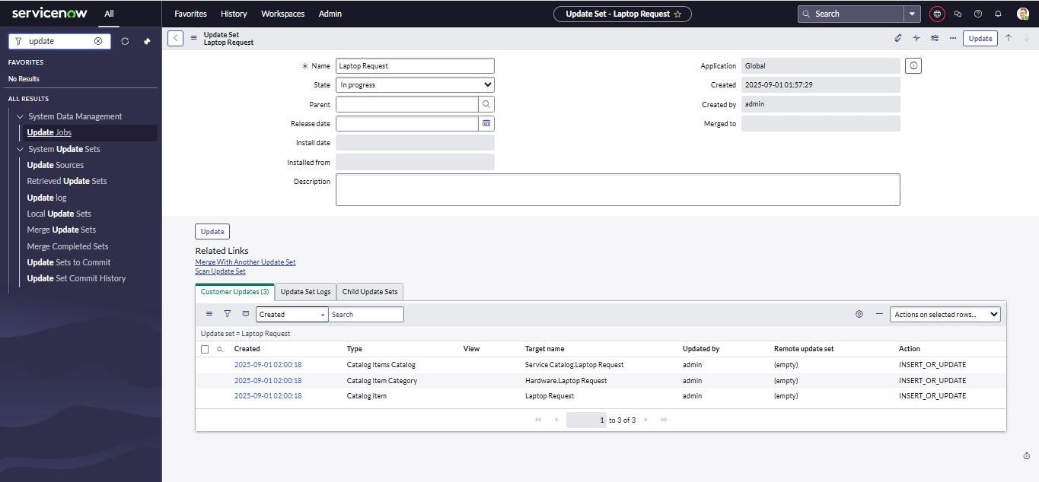

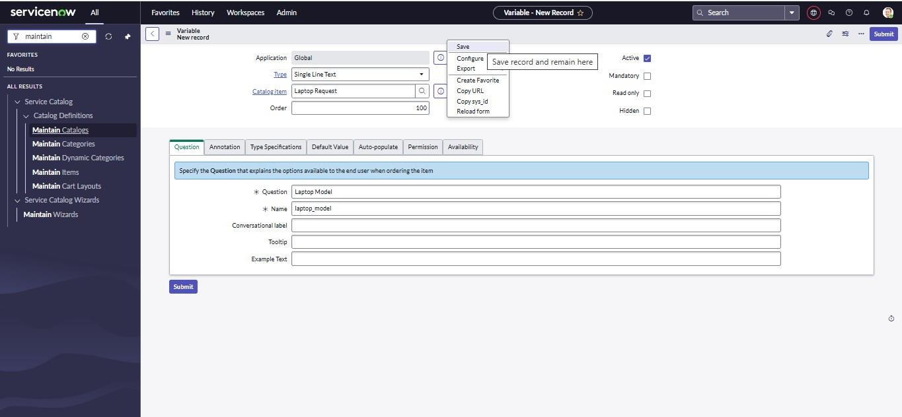



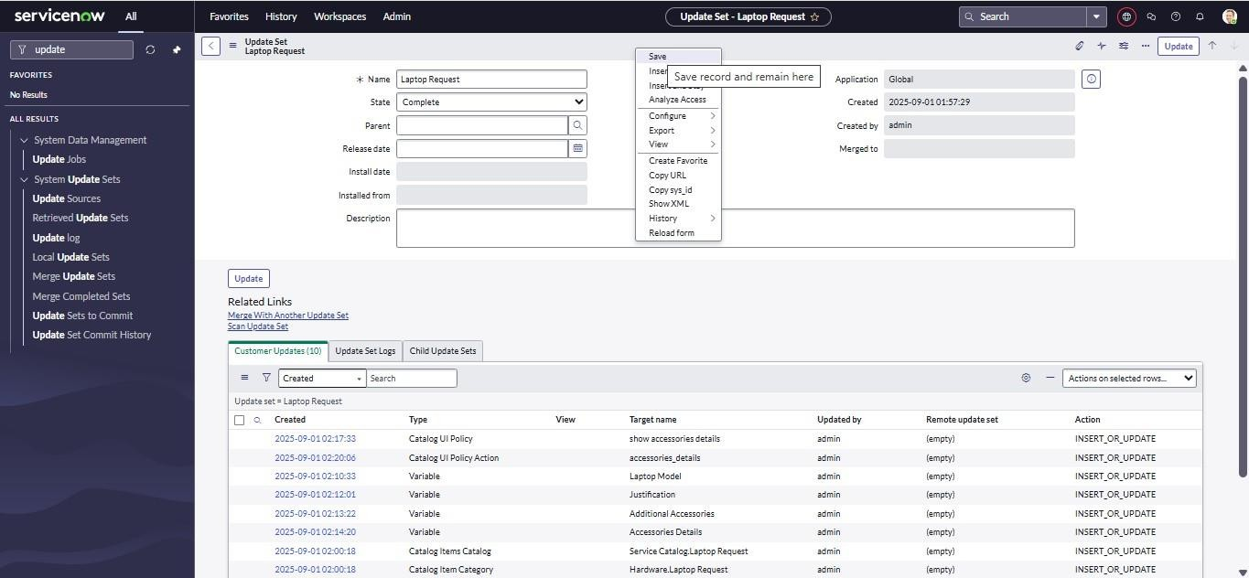

## Step 2: Create Service Catalog Item

Create a catalog item named Laptop Request and add required variables such as:  Laptop Model

 Justification

 Additional Accessories  Accessories Details

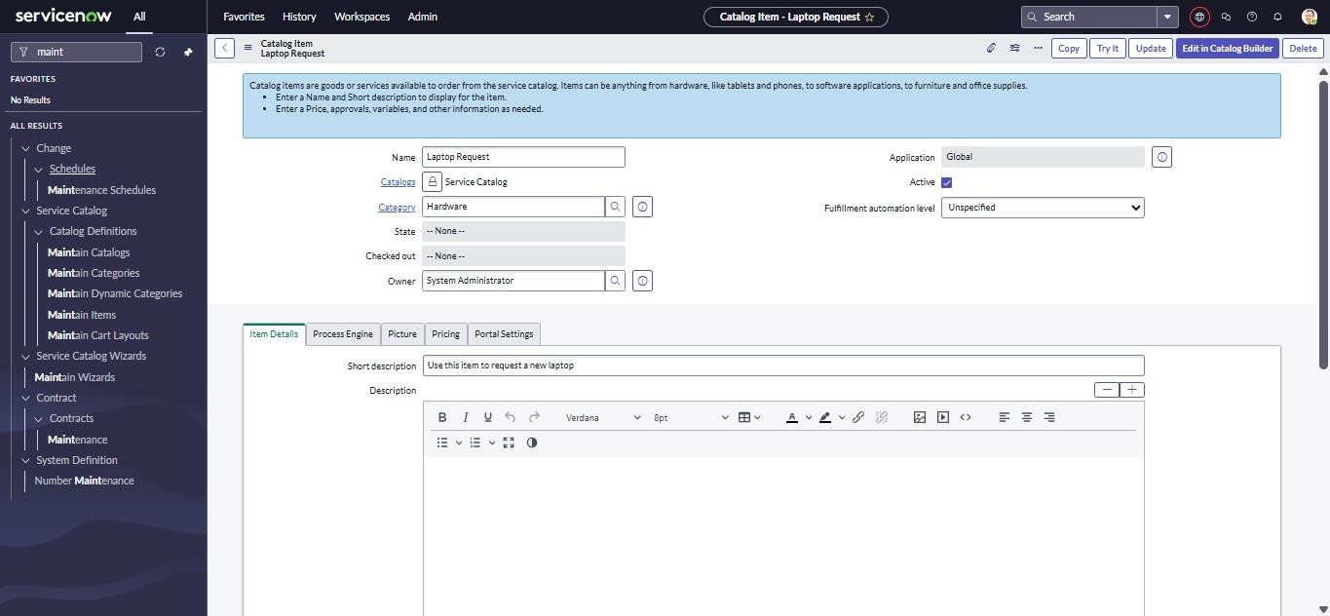

 

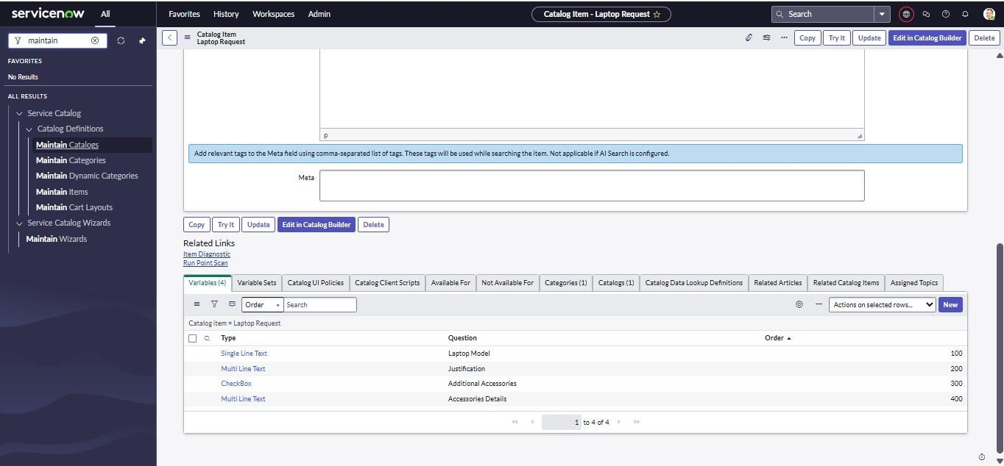

## Step 3: Add Catalog UI Policies

Create UI policies to:

 Show/hide fields based on selections  Make fields mandatory dynamically

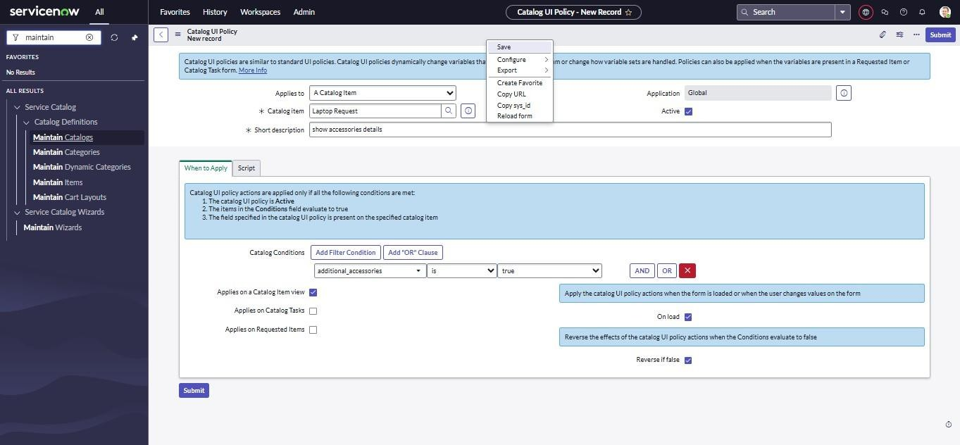

 

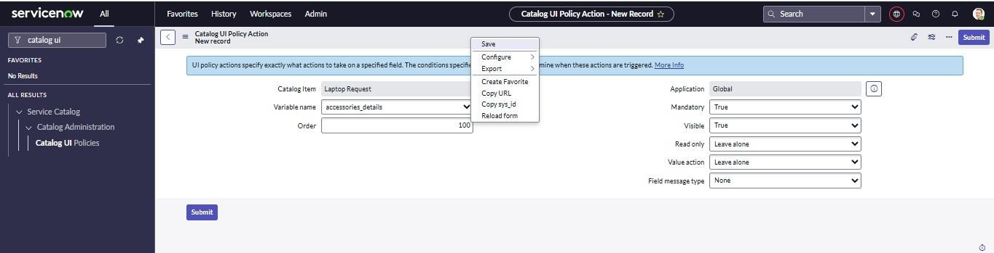

## Step 4: Create UI Action (Reset Form)

Add a Reset Form button using a client-side UI Action to clear the form inputs. Step 5: UI Action Create

1. Open service now.
2. Click on All >> search for ui action
3. Select ui actions under system definition
4. Click on new
5. Fill the following details to create ui action Table: shopping cart(sc_cart)

Order:100

Action name: Reset form Client : checked

Script:

function resetForm() {

g_form.clearForm(); // Clears all fields in the form alert("The form has been reset.");

}

Click on save

 

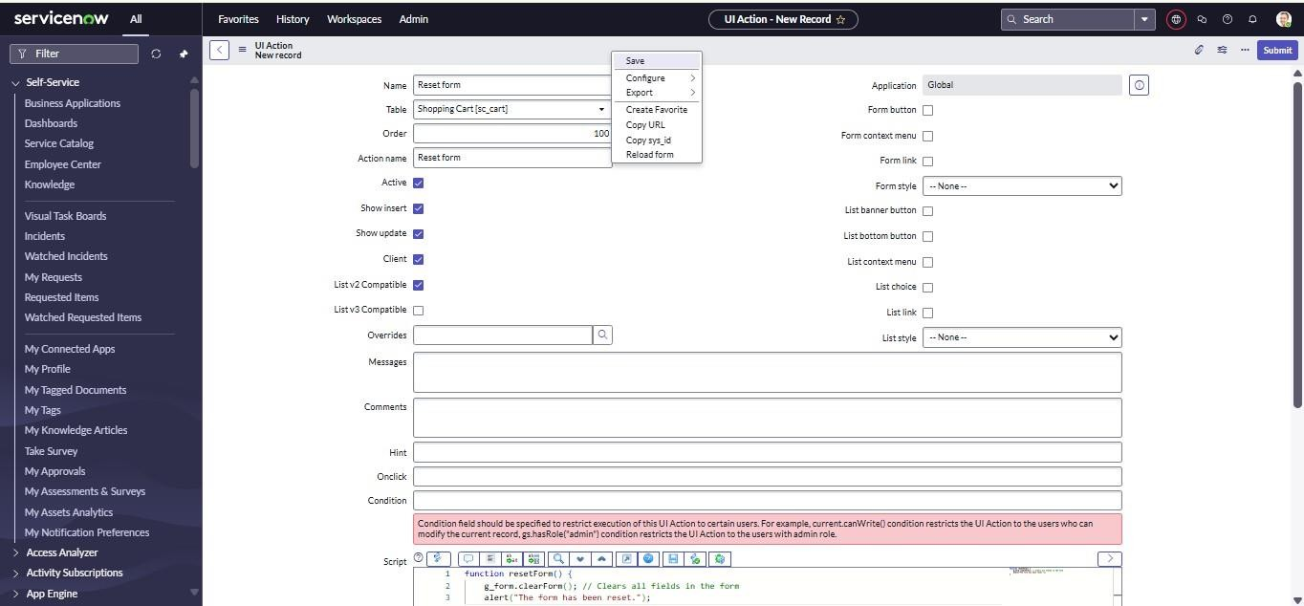

## Step 5: Export Changes

Export the update set to an XML file for reuse in other ServiceNow instances.

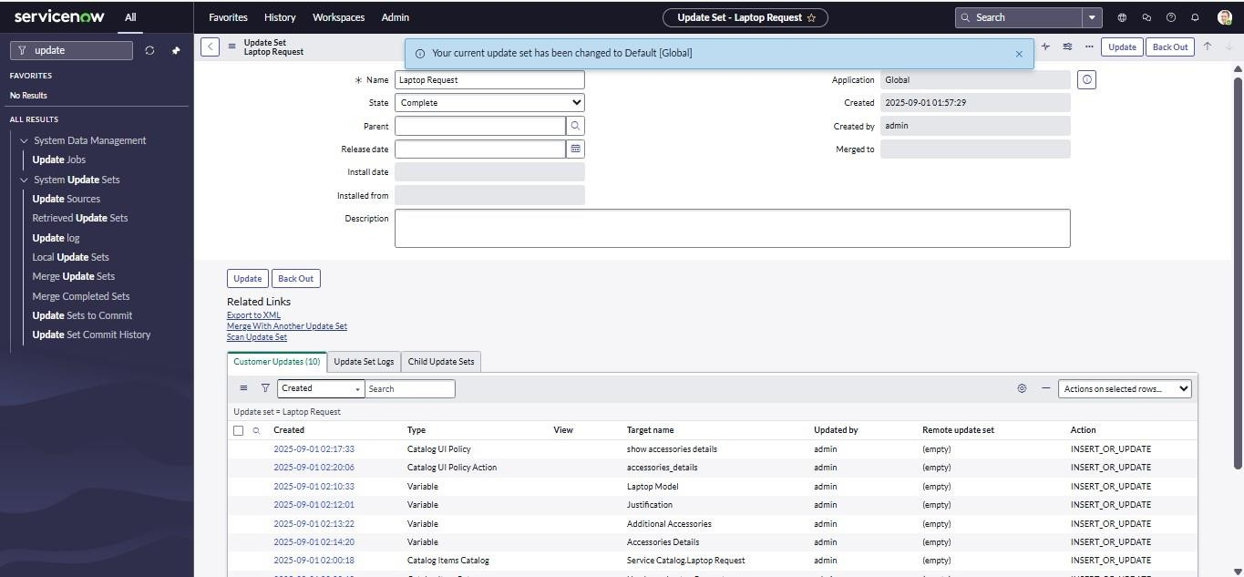

 

## Step 6: Import to Another Instance

Log in to a different ServiceNow instance and retrieve the update set.

**Exported XML file Program:**

<?xml version="1.0" encoding="UTF-8"?><unload unload_date="2025-10-25 08:45:35">

<sys_remote_update_set action="INSERT_OR_UPDATE">

<application display_value="Global">global</application>

<application_name>Global</application_name>

<application_scope>global</application_scope>

<application_version/>

<collisions/>

<commit_date/>

<deleted/>

<description/>

<inserted/>

<name>Laptop Request Project</name>

<origin_sys_id/>

<parent display_value=""/>

<release_date/>

<remote_base_update_set display_value=""/>

<remote_parent_id/>

<remote_sys_id>376d2a61c3b43a10ac245205e40131a9</remote_sys_id>

<state>loaded</state>

<summary/>

<sys_class_name>sys_remote_update_set</sys_class_name>

<sys_created_by>admin</sys_created_by>

<sys_created_on>2025-10-25 08:45:34</sys_created_on>

<sys_id>3fea6fa5c3747a10ac245205e4013139</sys_id>

<sys_mod_count>0</sys_mod_count>

<sys_updated_by>admin</sys_updated_by>

<sys_updated_on>2025-10-25 08:45:34</sys_updated_on>

<update_set display_value=""/>

<update_source display_value=""/>

<updated/>

</sys_remote_update_set>

<sys_update_xml action="INSERT_OR_UPDATE">

<action>INSERT_OR_UPDATE</action>

<application display_value="Global">global</application>

<category>customer</category>

<comments/>

<name>item_option_new_1eee6e29c3bc3a10ac245205e40131dc</name>

<payload>&lt;?xml version="1.0" encoding="UTF-8"?&gt;&lt;record_update table="item_option_new"&gt;&lt;item_option_new action="INSERT_OR_UPDATE"&gt;&lt;active&gt;true&lt;/active&gt;&lt;attributes/&gt;&lt;cat_item display_value="Laptop

 

Request"&gt;dc2e22e5c3bc3a10ac245205e40131c1&lt;/cat_item&gt;&lt;category/&gt;&lt;choice_direc tion&gt;down&lt;/choice_direction&gt;&lt;choice_field/&gt;&lt;choice_table/&gt;&lt;conversational_l abel/&gt;&lt;create_roles/&gt;&lt;default_html_value/&gt;&lt;default_value/&gt;&lt;delete_roles/&gt; &lt;delivery_plan/&gt;&lt;description/&gt;&lt;disable_initial_slot_fill&gt;false&lt;/disable_initial_slot_ fill&gt;&lt;display_title&gt;false&lt;/display_title&gt;&lt;do_not_select_first&gt;false&lt;/do_not_sele ct_first&gt;&lt;dynamic_default_value/&gt;&lt;dynamic_ref_qual/&gt;&lt;dynamic_value_dot_walk_p ath/&gt;&lt;dynamic_value_field/&gt;&lt;enable_also_request_for&gt;false&lt;/enable_also_request_fo r&gt;&lt;example_text/&gt;&lt;field/&gt;&lt;global&gt;false&lt;/global&gt;&lt;help_tag&gt;More information&lt;/help_tag&gt;&lt;help_text/&gt;&lt;hidden&gt;false&lt;/hidden&gt;&lt;include_none& gt;false&lt;/include_none&gt;&lt;instructions/&gt;&lt;layout&gt;normal&lt;/layout&gt;&lt;list_table/& gt;&lt;lookup_dependent_question/&gt;&lt;lookup_label/&gt;&lt;lookup_price/&gt;&lt;lookup_source/ &gt;&lt;lookup_table/&gt;&lt;lookup_unique&gt;false&lt;/lookup_unique&gt;&lt;lookup_value/&gt;& lt;macro/&gt;&lt;macroponent/&gt;&lt;mandatory&gt;false&lt;/mandatory&gt;&lt;map_to_field&gt;fal se&lt;/map_to_field&gt;&lt;mask_use_confirmation&gt;false&lt;/mask_use_confirmation&gt;&lt;mask

_use_encryption&gt;false&lt;/mask_use_encryption&gt;&lt;name&gt;justification&lt;/name&gt;&lt;not

_available_conversation&gt;false&lt;/not_available_conversation&gt;&lt;order&gt;200&lt;/order&gt;& lt;post_insert_script/&gt;&lt;price_if_checked&gt;0&lt;/price_if_checked&gt;&lt;pricing_implications &gt;false&lt;/pricing_implications&gt;&lt;published_ref/&gt;&lt;question_text&gt;Justification&lt;/que stion_text&gt;&lt;read_only&gt;false&lt;/read_only&gt;&lt;read_roles/&gt;&lt;read_script/&gt;&lt;rec

_lookup_price/&gt;&lt;rec_price_if_checked&gt;0&lt;/rec_price_if_checked&gt;&lt;record/&gt;&lt;rec ord_producer_table/&gt;&lt;reference/&gt;&lt;reference_qual/&gt;&lt;reference_qual_condition/&gt;& lt;rich_text/&gt;&lt;roles_to_use_also_request_for/&gt;&lt;save_script&gt;&lt;![CDATA[/** This script is executed before the Record is generated

* `current`- GlideRecord produced by Record Producer
* Don't use `current.update()` or `current.insert()` as the record is generated by Record Producer
* Don't use `current.setValue('sys_class_name', 'xxx')` as this will trigger reparent flow and can cause data loss
* Avoid `current.setAbortAction()` and generate a separate record
* Use `producer.var1` to access variables

*/]]&gt;&lt;/save_script&gt;&lt;scale_max&gt;5&lt;/scale_max&gt;&lt;scale_min&gt;0&lt;/scale_min &gt;&lt;show_help&gt;false&lt;/show_help&gt;&lt;show_help_on_load&gt;false&lt;/show_help_on_lo ad&gt;&lt;sp_widget/&gt;&lt;summary_macro/&gt;&lt;sys_class_name&gt;item_option_new&lt;/sys_c lass_name&gt;&lt;sys_created_by&gt;admin&lt;/sys_created_by&gt;&lt;sys_created_on&gt;2025-10- 25

04:23:51&lt;/sys_created_on&gt;&lt;sys_id&gt;1eee6e29c3bc3a10ac245205e40131dc&lt;/sys_id&gt;& lt;sys_mod_count&gt;0&lt;/sys_mod_count&gt;&lt;sys_name&gt;Justification&lt;/sys_name&gt;&lt;sy s_package display_value="Global" source="global"&gt;global&lt;/sys_package&gt;&lt;sys_policy/&gt;&lt;sys_scope display_value="Global"&gt;global&lt;/sys_scope&gt;&lt;sys_update_name&gt;item_option_new_1eee 6e29c3bc3a10ac245205e40131dc&lt;/sys_update_name&gt;&lt;sys_updated_by&gt;admin&lt;/sys_upd ated_by&gt;&lt;sys_updated_on&gt;2025-10-25 04:23:51&lt;/sys_updated_on&gt;&lt;table/&gt;&lt;tooltip/&gt;&lt;topic_block/&gt;&lt;type&gt;2&lt;/t ype&gt;&lt;ui_page/&gt;&lt;unique&gt;false&lt;/unique&gt;&lt;use_dynamic_default&gt;false&lt;/use

_dynamic_default&gt;&lt;use_reference_qualifier&gt;simple&lt;/use_reference_qualifier&gt;&lt;valida te_regex/&gt;&lt;variable_name/&gt;&lt;variable_set/&gt;&lt;variable_width/&gt;&lt;visibility&gt;1&l t;/visibility&gt;&lt;visible_bundle&gt;true&lt;/visible_bundle&gt;&lt;visible_guide&gt;true&lt;/visible

_guide&gt;&lt;visible_standalone&gt;true&lt;/visible_standalone&gt;&lt;visible_summary&gt;true&lt;/ visible_summary&gt;&lt;write_roles/&gt;&lt;/item_option_new&gt;&lt;sys_translated_text action="delete_multiple" query="documentkey=1eee6e29c3bc3a10ac245205e40131dc"/&gt;&lt;fx_price action="delete_multiple" query="id=1eee6e29c3bc3a10ac245205e40131dc"/&gt;&lt;fx_price

 

action="INSERT_OR_UPDATE"&gt;&lt;amount&gt;0&lt;/amount&gt;&lt;currency display_value="GBP"&gt;GBP&lt;/currency&gt;&lt;field&gt;price_if_checked&lt;/field&gt;&lt;id&gt; 1eee6e29c3bc3a10ac245205e40131dc&lt;/id&gt;&lt;parent/&gt;&lt;reference_amount&gt;0&lt;/referen ce_amount&gt;&lt;reference_currency display_value="USD"&gt;USD&lt;/reference_currency&gt;&lt;sys_created_by&gt;admin&lt;/sys_creat ed_by&gt;&lt;sys_created_on&gt;2025-10-25 04:23:51&lt;/sys_created_on&gt;&lt;sys_id&gt;920fa269c3bc3a10ac245205e4013127&lt;/sys_id&gt;& lt;sys_mod_count&gt;0&lt;/sys_mod_count&gt;&lt;sys_updated_by&gt;admin&lt;/sys_updated_by&gt; &lt;sys_updated_on&gt;2025-10-25 04:23:51&lt;/sys_updated_on&gt;&lt;table&gt;item_option_new&lt;/table&gt;&lt;type&gt;calculated& lt;/type&gt;&lt;/fx_price&gt;&lt;fx_price action="INSERT_OR_UPDATE"&gt;&lt;amount&gt;0&lt;/amount&gt;&lt;currency display_value="GBP"&gt;GBP&lt;/currency&gt;&lt;field&gt;rec_price_if_checked&lt;/field&gt;&lt;id &gt;1eee6e29c3bc3a10ac245205e40131dc&lt;/id&gt;&lt;parent/&gt;&lt;reference_amount&gt;0&lt;/re ference_amount&gt;&lt;reference_currency display_value="USD"&gt;USD&lt;/reference_currency&gt;&lt;sys_created_by&gt;admin&lt;/sys_creat ed_by&gt;&lt;sys_created_on&gt;2025-10-25 04:23:51&lt;/sys_created_on&gt;&lt;sys_id&gt;de0fa269c3bc3a10ac245205e4013125&lt;/sys_id&gt;& lt;sys_mod_count&gt;0&lt;/sys_mod_count&gt;&lt;sys_updated_by&gt;admin&lt;/sys_updated_by&gt; &lt;sys_updated_on&gt;2025-10-25 04:23:51&lt;/sys_updated_on&gt;&lt;table&gt;item_option_new&lt;/table&gt;&lt;type&gt;calculated& lt;/type&gt;&lt;/fx_price&gt;&lt;/record_update&gt;</payload>

<payload_hash>1937587050</payload_hash>

<remote_update_set display_value="Laptop Request Project">3fea6fa5c3747a10ac245205e4013139</remote_update_set>

<replace_on_upgrade>false</replace_on_upgrade>

<sys_created_by>admin</sys_created_by>

<sys_created_on>2025-10-25 08:45:34</sys_created_on>

<sys_id>37ea6fa5c3747a10ac245205e401313b</sys_id>

<sys_mod_count>0</sys_mod_count>

<sys_recorded_at>19a199bcbfe0000001</sys_recorded_at>

<sys_updated_by>admin</sys_updated_by>

<sys_updated_on>2025-10-25 08:45:34</sys_updated_on>

<table/>

<target_name>Justification</target_name>

<type>Variable</type>

<update_domain>global</update_domain>

<update_guid>160fa26974bc3a10f72bb4ce233bee2b</update_guid>

<update_guid_history>160fa26974bc3a10f72bb4ce233bee2b:1937587050</update_guid_history>

<update_set display_value=""/>

<view/>

</sys_update_xml>

<sys_update_xml action="INSERT_OR_UPDATE">

<action>INSERT_OR_UPDATE</action>

<application display_value="Global">global</application>

<category>customer</category>

<comments/>

<name>item_option_new_fc4f6ae5c3bc3a10ac245205e4013165</name>

<payload>&lt;?xml version="1.0" encoding="UTF-8"?&gt;&lt;record_update table="item_option_new"&gt;&lt;item_option_new action="INSERT_OR_UPDATE"&gt;&lt;active&gt;true&lt;/active&gt;&lt;attributes/&gt;&lt;cat_item

 

display_value="Laptop Request"&gt;dc2e22e5c3bc3a10ac245205e40131c1&lt;/cat_item&gt;&lt;category/&gt;&lt;choice_direc tion&gt;down&lt;/choice_direction&gt;&lt;choice_field/&gt;&lt;choice_table/&gt;&lt;conversational_l abel/&gt;&lt;create_roles/&gt;&lt;default_html_value/&gt;&lt;default_value/&gt;&lt;delete_roles/&gt; &lt;delivery_plan/&gt;&lt;description/&gt;&lt;disable_initial_slot_fill&gt;false&lt;/disable_initial_slot_ fill&gt;&lt;display_title&gt;false&lt;/display_title&gt;&lt;do_not_select_first&gt;false&lt;/do_not_sele ct_first&gt;&lt;dynamic_default_value/&gt;&lt;dynamic_ref_qual/&gt;&lt;dynamic_value_dot_walk_p ath/&gt;&lt;dynamic_value_field/&gt;&lt;enable_also_request_for&gt;false&lt;/enable_also_request_fo r&gt;&lt;example_text/&gt;&lt;field/&gt;&lt;global&gt;false&lt;/global&gt;&lt;help_tag&gt;More information&lt;/help_tag&gt;&lt;help_text/&gt;&lt;hidden&gt;false&lt;/hidden&gt;&lt;include_none& gt;false&lt;/include_none&gt;&lt;instructions/&gt;&lt;layout&gt;normal&lt;/layout&gt;&lt;list_table/& gt;&lt;lookup_dependent_question/&gt;&lt;lookup_label/&gt;&lt;lookup_price/&gt;&lt;lookup_source/ &gt;&lt;lookup_table/&gt;&lt;lookup_unique&gt;false&lt;/lookup_unique&gt;&lt;lookup_value/&gt;& lt;macro/&gt;&lt;macroponent/&gt;&lt;mandatory&gt;false&lt;/mandatory&gt;&lt;map_to_field&gt;fal se&lt;/map_to_field&gt;&lt;mask_use_confirmation&gt;false&lt;/mask_use_confirmation&gt;&lt;mask

_use_encryption&gt;false&lt;/mask_use_encryption&gt;&lt;name&gt;accessories_details&lt;/name&gt; &lt;not_available_conversation&gt;false&lt;/not_available_conversation&gt;&lt;order&gt;400&lt;/orde r&gt;&lt;post_insert_script/&gt;&lt;price_if_checked&gt;0&lt;/price_if_checked&gt;&lt;pricing_implic ations&gt;false&lt;/pricing_implications&gt;&lt;published_ref/&gt;&lt;question_text&gt;Accessories Details&lt;/question_text&gt;&lt;read_only&gt;false&lt;/read_only&gt;&lt;read_roles/&gt;&lt;read_scr ipt/&gt;&lt;rec_lookup_price/&gt;&lt;rec_price_if_checked&gt;0&lt;/rec_price_if_checked&gt;&lt;rec ord/&gt;&lt;record_producer_table/&gt;&lt;reference/&gt;&lt;reference_qual/&gt;&lt;reference_qual_c ondition/&gt;&lt;rich_text/&gt;&lt;roles_to_use_also_request_for/&gt;&lt;save_script&gt;&lt;![CDAT A[/** This script is executed before the Record is generated

* `current`- GlideRecord produced by Record Producer
* Don't use `current.update()` or `current.insert()` as the record is generated by Record Producer
* Don't use `current.setValue('sys_class_name', 'xxx')` as this will trigger reparent flow and can cause data loss
* Avoid `current.setAbortAction()` and generate a separate record
* Use `producer.var1` to access variables

*/]]&gt;&lt;/save_script&gt;&lt;scale_max&gt;5&lt;/scale_max&gt;&lt;scale_min&gt;0&lt;/scale_min &gt;&lt;show_help&gt;false&lt;/show_help&gt;&lt;show_help_on_load&gt;false&lt;/show_help_on_lo ad&gt;&lt;sp_widget/&gt;&lt;summary_macro/&gt;&lt;sys_class_name&gt;item_option_new&lt;/sys_c lass_name&gt;&lt;sys_created_by&gt;admin&lt;/sys_created_by&gt;&lt;sys_created_on&gt;2025-10- 25

04:25:04&lt;/sys_created_on&gt;&lt;sys_id&gt;fc4f6ae5c3bc3a10ac245205e4013165&lt;/sys_id&gt;&l t;sys_mod_count&gt;0&lt;/sys_mod_count&gt;&lt;sys_name&gt;Accessories Details&lt;/sys_name&gt;&lt;sys_package display_value="Global" source="global"&gt;global&lt;/sys_package&gt;&lt;sys_policy/&gt;&lt;sys_scope display_value="Global"&gt;global&lt;/sys_scope&gt;&lt;sys_update_name&gt;item_option_new_fc4f6 ae5c3bc3a10ac245205e4013165&lt;/sys_update_name&gt;&lt;sys_updated_by&gt;admin&lt;/sys_upda ted_by&gt;&lt;sys_updated_on&gt;2025-10-25 04:25:04&lt;/sys_updated_on&gt;&lt;table/&gt;&lt;tooltip/&gt;&lt;topic_block/&gt;&lt;type&gt;2&lt;/t ype&gt;&lt;ui_page/&gt;&lt;unique&gt;false&lt;/unique&gt;&lt;use_dynamic_default&gt;false&lt;/use

_dynamic_default&gt;&lt;use_reference_qualifier&gt;simple&lt;/use_reference_qualifier&gt;&lt;valida te_regex/&gt;&lt;variable_name/&gt;&lt;variable_set/&gt;&lt;variable_width/&gt;&lt;visibility&gt;1&l t;/visibility&gt;&lt;visible_bundle&gt;true&lt;/visible_bundle&gt;&lt;visible_guide&gt;true&lt;/visible

_guide&gt;&lt;visible_standalone&gt;true&lt;/visible_standalone&gt;&lt;visible_summary&gt;true&lt;/ visible_summary&gt;&lt;write_roles/&gt;&lt;/item_option_new&gt;&lt;sys_translated_text action="delete_multiple" query="documentkey=fc4f6ae5c3bc3a10ac245205e4013165"/&gt;&lt;fx_price

 

action="delete_multiple" query="id=fc4f6ae5c3bc3a10ac245205e4013165"/&gt;&lt;fx_price action="INSERT_OR_UPDATE"&gt;&lt;amount&gt;0&lt;/amount&gt;&lt;currency display_value="GBP"&gt;GBP&lt;/currency&gt;&lt;field&gt;price_if_checked&lt;/field&gt;&lt;id&gt; fc4f6ae5c3bc3a10ac245205e4013165&lt;/id&gt;&lt;parent/&gt;&lt;reference_amount&gt;0&lt;/referen ce_amount&gt;&lt;reference_currency display_value="USD"&gt;USD&lt;/reference_currency&gt;&lt;sys_created_by&gt;admin&lt;/sys_creat ed_by&gt;&lt;sys_created_on&gt;2025-10-25 04:25:05&lt;/sys_created_on&gt;&lt;sys_id&gt;c85fea69c3bc3a10ac245205e4013118&lt;/sys_id&gt;& lt;sys_mod_count&gt;0&lt;/sys_mod_count&gt;&lt;sys_updated_by&gt;admin&lt;/sys_updated_by&gt; &lt;sys_updated_on&gt;2025-10-25 04:25:05&lt;/sys_updated_on&gt;&lt;table&gt;item_option_new&lt;/table&gt;&lt;type&gt;calculated& lt;/type&gt;&lt;/fx_price&gt;&lt;fx_price action="INSERT_OR_UPDATE"&gt;&lt;amount&gt;0&lt;/amount&gt;&lt;currency display_value="GBP"&gt;GBP&lt;/currency&gt;&lt;field&gt;rec_price_if_checked&lt;/field&gt;&lt;id &gt;fc4f6ae5c3bc3a10ac245205e4013165&lt;/id&gt;&lt;parent/&gt;&lt;reference_amount&gt;0&lt;/ref erence_amount&gt;&lt;reference_currency display_value="USD"&gt;USD&lt;/reference_currency&gt;&lt;sys_created_by&gt;admin&lt;/sys_creat ed_by&gt;&lt;sys_created_on&gt;2025-10-25 04:25:05&lt;/sys_created_on&gt;&lt;sys_id&gt;085fea69c3bc3a10ac245205e4013117&lt;/sys_id&gt;& lt;sys_mod_count&gt;0&lt;/sys_mod_count&gt;&lt;sys_updated_by&gt;admin&lt;/sys_updated_by&gt; &lt;sys_updated_on&gt;2025-10-25 04:25:05&lt;/sys_updated_on&gt;&lt;table&gt;item_option_new&lt;/table&gt;&lt;type&gt;calculated& lt;/type&gt;&lt;/fx_price&gt;&lt;/record_update&gt;</payload>

<payload_hash>710507467</payload_hash>

<remote_update_set display_value="Laptop Request Project">3fea6fa5c3747a10ac245205e4013139</remote_update_set>

<replace_on_upgrade>false</replace_on_upgrade>

<sys_created_by>admin</sys_created_by>

<sys_created_on>2025-10-25 08:45:34</sys_created_on>

<sys_id>37eae3a9c3747a10ac245205e4013136</sys_id>

<sys_mod_count>0</sys_mod_count>

<sys_recorded_at>19a199ce93a0000001</sys_recorded_at>

<sys_updated_by>admin</sys_updated_by>

<sys_updated_on>2025-10-25 08:45:34</sys_updated_on>

<table/>

<target_name>Accessories Details</target_name>

<type>Variable</type>

<update_domain>global</update_domain>

<update_guid>4c5fea6971bc3a107264480fca3afa1c</update_guid>

<update_guid_history>4c5fea6971bc3a107264480fca3afa1c:710507467</update_guid_history>

<update_set display_value=""/>

<view/>

</sys_update_xml>

<sys_update_xml action="INSERT_OR_UPDATE">

<action>INSERT_OR_UPDATE</action>

<application display_value="Global">global</application>

<category>customer</category>

<comments/>

<name>sys_ui_action_a891fe6dc3bc3a10ac245205e40131a0</name>

<payload>&lt;?xml version="1.0" encoding="UTF-8"?&gt;&lt;record_update sys_domain="global" table="sys_ui_action"&gt;&lt;sys_ui_action

 

action="INSERT_OR_UPDATE"&gt;&lt;action_name&gt;Reset form&lt;/action_name&gt;&lt;active&gt;true&lt;/active&gt;&lt;client&gt;true&lt;/client&gt;&lt;client_ script_v2&gt;&lt;![CDATA[function onClick(g_form) {

}]]&gt;&lt;/client_script_v2&gt;&lt;comments/&gt;&lt;condition/&gt;&lt;form_action&gt;false&lt;/for m_action&gt;&lt;form_button&gt;false&lt;/form_button&gt;&lt;form_button_v2&gt;false&lt;/form_bu tton_v2&gt;&lt;form_context_menu&gt;false&lt;/form_context_menu&gt;&lt;form_link&gt;false&lt;/f orm_link&gt;&lt;form_menu_button_v2&gt;false&lt;/form_menu_button_v2&gt;&lt;form_style/&gt;& lt;format_for_configurable_workspace&gt;false&lt;/format_for_configurable_workspace&gt;&lt;hint/& gt;&lt;isolate_script&gt;true&lt;/isolate_script&gt;&lt;list_action&gt;false&lt;/list_action&gt;&lt;list_b anner_button&gt;false&lt;/list_banner_button&gt;&lt;list_button&gt;false&lt;/list_button&gt;&lt;list_c hoice&gt;false&lt;/list_choice&gt;&lt;list_context_menu&gt;false&lt;/list_context_menu&gt;&lt;list_li nk&gt;false&lt;/list_link&gt;&lt;list_save_with_form_button&gt;false&lt;/list_save_with_form_button &gt;&lt;list_style/&gt;&lt;messages/&gt;&lt;name&gt;Reset form&lt;/name&gt;&lt;onclick/&gt;&lt;order&gt;100&lt;/order&gt;&lt;script&gt;&lt;![CDATA[functio n resetForm() {

g_form.clearForm(); // Clears all fields in the form alert("The form has been reset.");

}]]&gt;&lt;/script&gt;&lt;show_insert&gt;true&lt;/show_insert&gt;&lt;show_multiple_update&gt;false &lt;/show_multiple_update&gt;&lt;show_query&gt;false&lt;/show_query&gt;&lt;show_update&gt;true &lt;/show_update&gt;&lt;sys_class_name&gt;sys_ui_action&lt;/sys_class_name&gt;&lt;sys_created_b y&gt;admin&lt;/sys_created_by&gt;&lt;sys_created_on&gt;2025-10-25 04:37:46&lt;/sys_created_on&gt;&lt;sys_domain&gt;global&lt;/sys_domain&gt;&lt;sys_domain_path &gt;/&lt;/sys_domain_path&gt;&lt;sys_id&gt;a891fe6dc3bc3a10ac245205e40131a0&lt;/sys_id&gt;&lt

;sys_mod_count&gt;1&lt;/sys_mod_count&gt;&lt;sys_name&gt;Reset form&lt;/sys_name&gt;&lt;sys_overrides/&gt;&lt;sys_package display_value="Global" source="global"&gt;global&lt;/sys_package&gt;&lt;sys_policy/&gt;&lt;sys_scope display_value="Global"&gt;global&lt;/sys_scope&gt;&lt;sys_update_name&gt;sys_ui_action_a891fe6 dc3bc3a10ac245205e40131a0&lt;/sys_update_name&gt;&lt;sys_updated_by&gt;admin&lt;/sys_update d_by&gt;&lt;sys_updated_on&gt;2025-10-25 04:38:24&lt;/sys_updated_on&gt;&lt;table&gt;sc_cart&lt;/table&gt;&lt;ui11_compatible&gt;true&lt;/ui 11_compatible&gt;&lt;ui16_compatible&gt;false&lt;/ui16_compatible&gt;&lt;/sys_ui_action&gt;&lt;/r ecord_update&gt;</payload>

<payload_hash>1669134333</payload_hash>

<remote_update_set display_value="Laptop Request Project">3fea6fa5c3747a10ac245205e4013139</remote_update_set>

<replace_on_upgrade>false</replace_on_upgrade>

<sys_created_by>admin</sys_created_by>

<sys_created_on>2025-10-25 08:45:34</sys_created_on>

<sys_id>3beae3a9c3747a10ac245205e4013137</sys_id>

<sys_mod_count>0</sys_mod_count>

<sys_recorded_at>19a19a91a670000001</sys_recorded_at>

<sys_updated_by>admin</sys_updated_by>

<sys_updated_on>2025-10-25 08:45:34</sys_updated_on>

<table>sc_cart</table>

<target_name>Reset form</target_name>

<type>UI Action</type>

<update_domain>global</update_domain>

<update_guid>5352fe6d8bbc3a10c60c0fe6dd31f6ce</update_guid>

<update_guid_history>5352fe6d8bbc3a10c60c0fe6dd31f6ce:1669134333,ca32b2edeebc3a100e48e5d10 0f751a3:-1815082223</update_guid_history>

 

<update_set display_value=""/>

<view/>

</sys_update_xml>

<sys_update_xml action="INSERT_OR_UPDATE">

<action>INSERT_OR_UPDATE</action>

<application display_value="Global">global</application>

<category>customer</category>

<comments/>

<name>catalog_ui_policy_action_2f80722dc3bc3a10ac245205e401318d</name>

<payload><![CDATA[<?xml version="1.0" encoding="UTF-8"?><record_update table="catalog_ui_policy_action"><catalog_ui_policy_action action="INSERT_OR_UPDATE"><catalog_item display_value="Laptop Request">dc2e22e5c3bc3a10ac245205e40131c1</catalog_item><catalog_variable>IO:fc4f6ae5c3bc3a 10ac245205e4013165</catalog_variable><cleared>false</cleared><disabled>ignore</disabled><field/

><field_message/><field_message_type>none</field_message_type><mandatory>true</mandatory><o rder>100</order><sys_class_name>catalog_ui_policy_action</sys_class_name><sys_created_by>admi n</sys_created_by><sys_created_on>2025-10-25 04:31:20</sys_created_on><sys_id>2f80722dc3bc3a10ac245205e401318d</sys_id><sys_mod_count> 0</sys_mod_count><sys_name>accessories_details</sys_name><sys_package display_value="Global" source="global">global</sys_package><sys_policy/><sys_scope display_value="Global">global</sys_scope><sys_update_name>catalog_ui_policy_action_2f80722dc3 bc3a10ac245205e401318d</sys_update_name><sys_updated_by>admin</sys_updated_by><sys_updat ed_on>2025-10-25 04:31:20</sys_updated_on><table/><ui_policy display_value="show accessories details">f6ef6ea9c3bc3a10ac245205e40131f9</ui_policy><value/><value_action>ignore</value_actio n><variable>accessories_details</variable><variable_set/><visible>true</visible></catalog_ui_policy_ action><sys_translated_text action="delete_multiple" query="documentkey=2f80722dc3bc3a10ac245205e401318d"/></record_update>]]></payload>

<payload_hash>-1041227987</payload_hash>

<remote_update_set display_value="Laptop Request Project">3fea6fa5c3747a10ac245205e4013139</remote_update_set>

<replace_on_upgrade>false</replace_on_upgrade>

<sys_created_by>admin</sys_created_by>

<sys_created_on>2025-10-25 08:45:34</sys_created_on>

<sys_id>73ea6fa5c3747a10ac245205e401313a</sys_id>

<sys_mod_count>0</sys_mod_count>

<sys_recorded_at>19a19a2a5010000001</sys_recorded_at>

<sys_updated_by>admin</sys_updated_by>

<sys_updated_on>2025-10-25 08:45:34</sys_updated_on>

<table/>

<target_name>accessories_details</target_name>

<type>Catalog UI Policy Action</type>

<update_domain>global</update_domain>

<update_guid>3bb0b62d15bc3a1034ec8c81cd7a14e5</update_guid>

<update_guid_history>3bb0b62d15bc3a1034ec8c81cd7a14e5:-1041227987</update_guid_history>

<update_set display_value=""/>

<view/>

</sys_update_xml>

<sys_update_xml action="INSERT_OR_UPDATE">

<action>INSERT_OR_UPDATE</action>

<application display_value="Global">global</application>

<category>customer</category>

 

<comments/>

<name>sc_cat_item_catalog_f26e6ae5c3bc3a10ac245205e4013139</name>

<payload><![CDATA[<?xml version="1.0" encoding="UTF-8"?><record_update table="sc_cat_item_catalog"><sc_cat_item_catalog action="INSERT_OR_UPDATE"><sc_cat_item display_value="Laptop Request">dc2e22e5c3bc3a10ac245205e40131c1</sc_cat_item><sc_catalog display_value="Service Catalog">e0d08b13c3330100c8b837659bba8fb4</sc_catalog><sys_class_name>sc_cat_item_catalog</ sys_class_name><sys_created_by>admin</sys_created_by><sys_created_on>2025-10-25 04:21:10</sys_created_on><sys_id>f26e6ae5c3bc3a10ac245205e4013139</sys_id><sys_mod_count> 0</sys_mod_count><sys_name>Service Catalog.Laptop Request</sys_name><sys_package display_value="Global" source="global">global</sys_package><sys_policy/><sys_scope display_value="Global">global</sys_scope><sys_update_name>sc_cat_item_catalog_f26e6ae5c3bc3a 10ac245205e4013139</sys_update_name><sys_updated_by>admin</sys_updated_by><sys_updated_o n>2025-10-25 04:21:10</sys_updated_on></sc_cat_item_catalog></record_update>]]></payload>

<payload_hash>-1071720869</payload_hash>

<remote_update_set display_value="Laptop Request Project">3fea6fa5c3747a10ac245205e4013139</remote_update_set>

<replace_on_upgrade>false</replace_on_upgrade>

<sys_created_by>admin</sys_created_by>

<sys_created_on>2025-10-25 08:45:34</sys_created_on>

<sys_id>7beae3a9c3747a10ac245205e4013136</sys_id>

<sys_mod_count>0</sys_mod_count>

<sys_recorded_at>19a199954f00000001</sys_recorded_at>

<sys_updated_by>admin</sys_updated_by>

<sys_updated_on>2025-10-25 08:45:34</sys_updated_on>

<table/>

<target_name>Service Catalog.Laptop Request</target_name>

<type>Catalog Items Catalog</type>

<update_domain>global</update_domain>

<update_guid>7a6e6ae551bc3a105cf582c334274a40</update_guid>

<update_guid_history>7a6e6ae551bc3a105cf582c334274a40:-1071720869</update_guid_history>

<update_set display_value=""/>

<view/>

</sys_update_xml>

<sys_update_xml action="INSERT_OR_UPDATE">

<action>INSERT_OR_UPDATE</action>

<application display_value="Global">global</application>

<category>customer</category>

<comments/>

<name>item_option_new_a3aee229c3bc3a10ac245205e4013102</name>

<payload>&lt;?xml version="1.0" encoding="UTF-8"?&gt;&lt;record_update table="item_option_new"&gt;&lt;item_option_new action="INSERT_OR_UPDATE"&gt;&lt;active&gt;true&lt;/active&gt;&lt;attributes/&gt;&lt;cat_item display_value="Laptop Request"&gt;dc2e22e5c3bc3a10ac245205e40131c1&lt;/cat_item&gt;&lt;category/&gt;&lt;choice_direc tion&gt;down&lt;/choice_direction&gt;&lt;choice_field/&gt;&lt;choice_table/&gt;&lt;conversational_l abel/&gt;&lt;create_roles/&gt;&lt;default_html_value/&gt;&lt;default_value/&gt;&lt;delete_roles/&gt; &lt;delivery_plan/&gt;&lt;description/&gt;&lt;disable_initial_slot_fill&gt;false&lt;/disable_initial_slot_ fill&gt;&lt;display_title&gt;false&lt;/display_title&gt;&lt;do_not_select_first&gt;false&lt;/do_not_sele ct_first&gt;&lt;dynamic_default_value/&gt;&lt;dynamic_ref_qual/&gt;&lt;dynamic_value_dot_walk_p ath/&gt;&lt;dynamic_value_field/&gt;&lt;enable_also_request_for&gt;false&lt;/enable_also_request_fo

 

r&gt;&lt;example_text/&gt;&lt;field/&gt;&lt;global&gt;false&lt;/global&gt;&lt;help_tag&gt;More information&lt;/help_tag&gt;&lt;help_text/&gt;&lt;hidden&gt;false&lt;/hidden&gt;&lt;include_none& gt;false&lt;/include_none&gt;&lt;instructions/&gt;&lt;layout&gt;normal&lt;/layout&gt;&lt;list_table/& gt;&lt;lookup_dependent_question/&gt;&lt;lookup_label/&gt;&lt;lookup_price/&gt;&lt;lookup_source/ &gt;&lt;lookup_table/&gt;&lt;lookup_unique&gt;false&lt;/lookup_unique&gt;&lt;lookup_value/&gt;& lt;macro/&gt;&lt;macroponent/&gt;&lt;mandatory&gt;false&lt;/mandatory&gt;&lt;map_to_field&gt;fal se&lt;/map_to_field&gt;&lt;mask_use_confirmation&gt;false&lt;/mask_use_confirmation&gt;&lt;mask

_use_encryption&gt;false&lt;/mask_use_encryption&gt;&lt;name&gt;laptop_model&lt;/name&gt;&lt;n ot_available_conversation&gt;false&lt;/not_available_conversation&gt;&lt;order&gt;100&lt;/order&gt; &lt;post_insert_script/&gt;&lt;price_if_checked&gt;0&lt;/price_if_checked&gt;&lt;pricing_implication s&gt;false&lt;/pricing_implications&gt;&lt;published_ref/&gt;&lt;question_text&gt;Laptop Model&lt;/question_text&gt;&lt;read_only&gt;false&lt;/read_only&gt;&lt;read_roles/&gt;&lt;read_scri pt/&gt;&lt;rec_lookup_price/&gt;&lt;rec_price_if_checked&gt;0&lt;/rec_price_if_checked&gt;&lt;reco rd/&gt;&lt;record_producer_table/&gt;&lt;reference/&gt;&lt;reference_qual/&gt;&lt;reference_qual_co ndition/&gt;&lt;rich_text/&gt;&lt;roles_to_use_also_request_for/&gt;&lt;save_script&gt;&lt;![CDATA [/** This script is executed before the Record is generated

* `current`- GlideRecord produced by Record Producer
* Don't use `current.update()` or `current.insert()` as the record is generated by Record Producer
* Don't use `current.setValue('sys_class_name', 'xxx')` as this will trigger reparent flow and can cause data loss
* Avoid `current.setAbortAction()` and generate a separate record
* Use `producer.var1` to access variables

*/]]&gt;&lt;/save_script&gt;&lt;scale_max&gt;5&lt;/scale_max&gt;&lt;scale_min&gt;0&lt;/scale_min &gt;&lt;show_help&gt;false&lt;/show_help&gt;&lt;show_help_on_load&gt;false&lt;/show_help_on_lo ad&gt;&lt;sp_widget/&gt;&lt;summary_macro/&gt;&lt;sys_class_name&gt;item_option_new&lt;/sys_c lass_name&gt;&lt;sys_created_by&gt;admin&lt;/sys_created_by&gt;&lt;sys_created_on&gt;2025-10- 25

04:23:10&lt;/sys_created_on&gt;&lt;sys_id&gt;a3aee229c3bc3a10ac245205e4013102&lt;/sys_id&gt;& lt;sys_mod_count&gt;0&lt;/sys_mod_count&gt;&lt;sys_name&gt;Laptop Model&lt;/sys_name&gt;&lt;sys_package display_value="Global" source="global"&gt;global&lt;/sys_package&gt;&lt;sys_policy/&gt;&lt;sys_scope display_value="Global"&gt;global&lt;/sys_scope&gt;&lt;sys_update_name&gt;item_option_new_a3ae e229c3bc3a10ac245205e4013102&lt;/sys_update_name&gt;&lt;sys_updated_by&gt;admin&lt;/sys_upd ated_by&gt;&lt;sys_updated_on&gt;2025-10-25 04:23:10&lt;/sys_updated_on&gt;&lt;table/&gt;&lt;tooltip/&gt;&lt;topic_block/&gt;&lt;type&gt;6&lt;/t ype&gt;&lt;ui_page/&gt;&lt;unique&gt;false&lt;/unique&gt;&lt;use_dynamic_default&gt;false&lt;/use

_dynamic_default&gt;&lt;use_reference_qualifier&gt;simple&lt;/use_reference_qualifier&gt;&lt;valida te_regex/&gt;&lt;variable_name/&gt;&lt;variable_set/&gt;&lt;variable_width/&gt;&lt;visibility&gt;1&l t;/visibility&gt;&lt;visible_bundle&gt;true&lt;/visible_bundle&gt;&lt;visible_guide&gt;true&lt;/visible

_guide&gt;&lt;visible_standalone&gt;true&lt;/visible_standalone&gt;&lt;visible_summary&gt;true&lt;/ visible_summary&gt;&lt;write_roles/&gt;&lt;/item_option_new&gt;&lt;sys_translated_text action="delete_multiple" query="documentkey=a3aee229c3bc3a10ac245205e4013102"/&gt;&lt;fx_price action="delete_multiple" query="id=a3aee229c3bc3a10ac245205e4013102"/&gt;&lt;fx_price action="INSERT_OR_UPDATE"&gt;&lt;amount&gt;0&lt;/amount&gt;&lt;currency display_value="GBP"&gt;GBP&lt;/currency&gt;&lt;field&gt;price_if_checked&lt;/field&gt;&lt;id&gt; a3aee229c3bc3a10ac245205e4013102&lt;/id&gt;&lt;parent/&gt;&lt;reference_amount&gt;0&lt;/refere nce_amount&gt;&lt;reference_currency display_value="USD"&gt;USD&lt;/reference_currency&gt;&lt;sys_created_by&gt;admin&lt;/sys_creat ed_by&gt;&lt;sys_created_on&gt;2025-10-25 04:23:10&lt;/sys_created_on&gt;&lt;sys_id&gt;d4ee2e29c3bc3a10ac245205e4013147&lt;/sys_id&gt;&

 

lt;sys_mod_count&gt;0&lt;/sys_mod_count&gt;&lt;sys_updated_by&gt;admin&lt;/sys_updated_by&gt; &lt;sys_updated_on&gt;2025-10-25 04:23:10&lt;/sys_updated_on&gt;&lt;table&gt;item_option_new&lt;/table&gt;&lt;type&gt;calculated& lt;/type&gt;&lt;/fx_price&gt;&lt;fx_price action="INSERT_OR_UPDATE"&gt;&lt;amount&gt;0&lt;/amount&gt;&lt;currency display_value="GBP"&gt;GBP&lt;/currency&gt;&lt;field&gt;rec_price_if_checked&lt;/field&gt;&lt;id &gt;a3aee229c3bc3a10ac245205e4013102&lt;/id&gt;&lt;parent/&gt;&lt;reference_amount&gt;0&lt;/re ference_amount&gt;&lt;reference_currency display_value="USD"&gt;USD&lt;/reference_currency&gt;&lt;sys_created_by&gt;admin&lt;/sys_creat ed_by&gt;&lt;sys_created_on&gt;2025-10-25 04:23:10&lt;/sys_created_on&gt;&lt;sys_id&gt;14ee2e29c3bc3a10ac245205e4013146&lt;/sys_id&gt;& lt;sys_mod_count&gt;0&lt;/sys_mod_count&gt;&lt;sys_updated_by&gt;admin&lt;/sys_updated_by&gt; &lt;sys_updated_on&gt;2025-10-25 04:23:10&lt;/sys_updated_on&gt;&lt;table&gt;item_option_new&lt;/table&gt;&lt;type&gt;calculated& lt;/type&gt;&lt;/fx_price&gt;&lt;/record_update&gt;</payload>

<payload_hash>-1803172761</payload_hash>

<remote_update_set display_value="Laptop Request Project">3fea6fa5c3747a10ac245205e4013139</remote_update_set>

<replace_on_upgrade>false</replace_on_upgrade>

<sys_created_by>admin</sys_created_by>

<sys_created_on>2025-10-25 08:45:34</sys_created_on>

<sys_id>bbeae3a9c3747a10ac245205e4013135</sys_id>

<sys_mod_count>0</sys_mod_count>

<sys_recorded_at>19a199b2a980000001</sys_recorded_at>

<sys_updated_by>admin</sys_updated_by>

<sys_updated_on>2025-10-25 08:45:34</sys_updated_on>

<table/>

<target_name>Laptop Model</target_name>

<type>Variable</type>

<update_domain>global</update_domain>

<update_guid>5cee2e290cbc3a101efab21ac45f2c4b</update_guid>

<update_guid_history>5cee2e290cbc3a101efab21ac45f2c4b:-1803172761</update_guid_history>

<update_set display_value=""/>

<view/>

</sys_update_xml>

<sys_update_xml action="INSERT_OR_UPDATE">

<action>INSERT_OR_UPDATE</action>

<application display_value="Global">global</application>

<category>customer</category>

<comments/>

<name>sc_cat_item_category_fe6e6ae5c3bc3a10ac245205e4013142</name>

<payload><![CDATA[<?xml version="1.0" encoding="UTF-8"?><record_update table="sc_cat_item_category"><sc_cat_item_category action="INSERT_OR_UPDATE"><sc_cat_item display_value="Laptop Request">dc2e22e5c3bc3a10ac245205e40131c1</sc_cat_item><sc_category display_value="Hardware">d258b953c611227a0146101fb1be7c31</sc_category><sys_class_name>sc

_cat_item_category</sys_class_name><sys_created_by>admin</sys_created_by><sys_created_on>202 5-10-25

04:21:10</sys_created_on><sys_id>fe6e6ae5c3bc3a10ac245205e4013142</sys_id><sys_mod_count>0

</sys_mod_count><sys_name>Hardware.Laptop Request</sys_name><sys_package display_value="Global" source="global">global</sys_package><sys_policy/><sys_scope display_value="Global">global</sys_scope><sys_update_name>sc_cat_item_category_fe6e6ae5c3bc3

 

a10ac245205e4013142</sys_update_name><sys_updated_by>admin</sys_updated_by><sys_updated_ on>2025-10-25 04:21:10</sys_updated_on></sc_cat_item_category></record_update>]]></payload>

<payload_hash>1327402087</payload_hash>

<remote_update_set display_value="Laptop Request Project">3fea6fa5c3747a10ac245205e4013139</remote_update_set>

<replace_on_upgrade>false</replace_on_upgrade>

<sys_created_by>admin</sys_created_by>

<sys_created_on>2025-10-25 08:45:34</sys_created_on>

<sys_id>bfeae3a9c3747a10ac245205e4013136</sys_id>

<sys_mod_count>0</sys_mod_count>

<sys_recorded_at>19a1999552d0000001</sys_recorded_at>

<sys_updated_by>admin</sys_updated_by>

<sys_updated_on>2025-10-25 08:45:34</sys_updated_on>

<table/>

<target_name>Hardware.Laptop Request</target_name>

<type>Catalog Item Category</type>

<update_domain>global</update_domain>

<update_guid>b66e6ae5babc3a1028fcd0c7f6e76348</update_guid>

<update_guid_history>b66e6ae5babc3a1028fcd0c7f6e76348:1327402087</update_guid_history>

<update_set display_value=""/>

<view/>

</sys_update_xml>

<sys_update_xml action="INSERT_OR_UPDATE">

<action>INSERT_OR_UPDATE</action>

<application display_value="Global">global</application>

<category>customer</category>

<comments/>

<name>sc_cat_item_dc2e22e5c3bc3a10ac245205e40131c1</name>

<payload><![CDATA[<?xml version="1.0" encoding="UTF-8"?><record_update table="sc_cat_item"><sc_cat_item action="INSERT_OR_UPDATE"><access_type>restricted</access_type><active>true</active><availa bility>on_desktop</availability><billable>false</billable><category display_value="Hardware">d258b953c611227a0146101fb1be7c31</category><checked_out/><cost>0

</cost><custom_cart/><delivery_plan display_value="DEFAULT">523da512c611228900811a37c97c2014</delivery_plan><delivery_plan_s cript/><delivery_time>1970-01-03 00:00:00</delivery_time><description/><display_price_property>non_zero</display_price_property>< entitlement_script/><flow_designer_flow/><fulfillment_automation_level>unspecified</fulfillment_aut omation_level><group/><hide_sp>false</hide_sp><icon/><ignore_price>true</ignore_price><image/>

<location/><make_item_non_conversational>false</make_item_non_conversational><mandatory_attac hment>false</mandatory_attachment><meta/><mobile_hide_price>false</mobile_hide_price><mobile

_picture/><mobile_picture_type>use_desktop_picture</mobile_picture_type><model/><name>Laptop Request</name><no_attachment_v2>false</no_attachment_v2><no_cart>false</no_cart><no_cart_v2

>false</no_cart_v2><no_delivery_time_v2>false</no_delivery_time_v2><no_order>false</no_order>

<no_order_now>false</no_order_now><no_proceed_checkout>false</no_proceed_checkout><no_qua ntity>false</no_quantity><no_quantity_v2>false</no_quantity_v2><no_save_as_draft>false</no_save

_as_draft><no_search>false</no_search><no_wishlist_v2>false</no_wishlist_v2><omit_price>false</ omit_price><order>0</order><ordered_item_link/><owner display_value="System Administrator">6816f79cc0a8016401c5a33be04be441</owner><picture/><preview>JavaScript: popupOpenStandard("com.glideapp.servicecatalog_cat_item_view.do?v=1&amp;sysparm_id=dc2e22e5 c3bc3a10ac245205e40131c1&amp;sysparm_preview=true",

 

"summary");</preview><price>0</price><published_ref/><recurring_frequency/><recurring_price>0</ recurring_price><request_method/><roles/><sc_catalogs>e0d08b13c3330100c8b837659bba8fb4</sc_c atalogs><sc_ic_item_staging/><sc_ic_version/><sc_template/><short_description>Use this item to request a new laptop</short_description><show_variable_help_on_load>false</show_variable_help_on_load><start_ closed>false</start_closed><state/><sys_class_name>sc_cat_item</sys_class_name><sys_created_by> admin</sys_created_by><sys_created_on>2025-10-25 04:21:10</sys_created_on><sys_id>dc2e22e5c3bc3a10ac245205e40131c1</sys_id><sys_mod_count> 7</sys_mod_count><sys_name>Laptop Request</sys_name><sys_package display_value="Global" source="global">global</sys_package><sys_policy/><sys_scope display_value="Global">global</sys_scope><sys_update_name>sc_cat_item_dc2e22e5c3bc3a10ac245 205e40131c1</sys_update_name><sys_updated_by>system</sys_updated_by><sys_updated_on>2025

-10-25

04:31:20</sys_updated_on><taxonomy_topic/><template/><template_manager_roles/><type>item</ty pe><use_sc_layout>true</use_sc_layout><vendor/><version>7</version><visible_bundle>true</visibl e_bundle><visible_guide>true</visible_guide><visible_standalone>true</visible_standalone><workflo w/></sc_cat_item><sys_translated_text action="delete_multiple" query="documentkey=dc2e22e5c3bc3a10ac245205e40131c1"/><fx_price action="delete_multiple" query="id=dc2e22e5c3bc3a10ac245205e40131c1"/><fx_price action="INSERT_OR_UPDATE"><amount>0</amount><currency display_value="GBP">GBP</currency><field>price</field><id>dc2e22e5c3bc3a10ac245205e40131c1

</id><parent/><reference_amount>0</reference_amount><reference_currency display_value="USD">USD</reference_currency><sys_created_by>admin</sys_created_by><sys_crea ted_on>2025-10-25 04:21:10</sys_created_on><sys_id>766e6ae5c3bc3a10ac245205e4013128</sys_id><sys_mod_count> 0</sys_mod_count><sys_updated_by>admin</sys_updated_by><sys_updated_on>2025-10-25 04:21:10</sys_updated_on><table>sc_cat_item</table><type>calculated</type></fx_price><fx_price action="INSERT_OR_UPDATE"><amount>0</amount><currency display_value="USD">USD</currency><field>recurring_price</field><id>dc2e22e5c3bc3a10ac24520 5e40131c1</id><parent/><reference_amount>0</reference_amount><reference_currency display_value="USD">USD</reference_currency><sys_created_by>admin</sys_created_by><sys_crea ted_on>2025-10-25 04:21:10</sys_created_on><sys_id>3e6e6ae5c3bc3a10ac245205e4013136</sys_id><sys_mod_count> 0</sys_mod_count><sys_updated_by>admin</sys_updated_by><sys_updated_on>2025-10-25 04:21:10</sys_updated_on><table>sc_cat_item</table><type>calculated</type></fx_price></record_u pdate>]]></payload>

<payload_hash>-495717247</payload_hash>

<remote_update_set display_value="Laptop Request Project">3fea6fa5c3747a10ac245205e4013139</remote_update_set>

<replace_on_upgrade>false</replace_on_upgrade>

<sys_created_by>admin</sys_created_by>

<sys_created_on>2025-10-25 08:45:34</sys_created_on>

<sys_id>f3eae3a9c3747a10ac245205e4013137</sys_id>

<sys_mod_count>0</sys_mod_count>

<sys_recorded_at>19a19a2a4ea0000001</sys_recorded_at>

<sys_updated_by>admin</sys_updated_by>

<sys_updated_on>2025-10-25 08:45:34</sys_updated_on>

<table/>

<target_name>Laptop Request</target_name>

<type>Catalog Item</type>

<update_domain>global</update_domain>

 

<update_guid>37b0b62d01bc3a105648655f0ba7e7e1</update_guid>

<update_guid_history>37b0b62d01bc3a105648655f0ba7e7e1:- 495717247,9880fee966bc3a10dd0810561f7b9c15:1887871296,805fea69debc3a10cffa32054d176915:-

23507457,b13fa2690fbc3a106310bb64de4b0f91:- 1934886210,5a0fa2699bbc3a100592325687a26023:448702333,9cee2e29b0bc3a10c6f47155eb8c1d43:-

1462676420,cb6e6ae57bbc3a102428f4a5a8aca36a:920912123,be6e6ae5babc3a100bd904925d27ab5e:- 1274850805</update_guid_history>

<update_set display_value=""/>

<view/>

</sys_update_xml>

<sys_update_xml action="INSERT_OR_UPDATE">

<action>INSERT_OR_UPDATE</action>

<application display_value="Global">global</application>

<category>customer</category>

<comments/>

<name>catalog_ui_policy_f6ef6ea9c3bc3a10ac245205e40131f9</name>

<payload>&lt;?xml version="1.0" encoding="UTF-8"?&gt;&lt;record_update sys_domain="global" table="catalog_ui_policy"&gt;&lt;catalog_ui_policy action="INSERT_OR_UPDATE"&gt;&lt;active&gt;true&lt;/active&gt;&lt;applies_catalog&gt;true&lt;

/applies_catalog&gt;&lt;applies_req_item&gt;false&lt;/applies_req_item&gt;&lt;applies_sc_task&gt;fal se&lt;/applies_sc_task&gt;&lt;applies_target_record&gt;false&lt;/applies_target_record&gt;&lt;applies

_to&gt;item&lt;/applies_to&gt;&lt;catalog_conditions&gt;IO:ae1fa265c3bc3a10ac245205e401316d=tr ue^EQ&lt;/catalog_conditions&gt;&lt;catalog_item display_value="Laptop Request"&gt;dc2e22e5c3bc3a10ac245205e40131c1&lt;/catalog_item&gt;&lt;conditions/&gt;&lt;descri ption/&gt;&lt;global&gt;true&lt;/global&gt;&lt;inherit&gt;false&lt;/inherit&gt;&lt;isolate_script&gt;tr ue&lt;/isolate_script&gt;&lt;model_id/&gt;&lt;model_table/&gt;&lt;on_load&gt;true&lt;/on_load&gt; &lt;order&gt;100&lt;/order&gt;&lt;published_ref/&gt;&lt;reverse_if_false&gt;true&lt;/reverse_if_false &gt;&lt;run_scripts&gt;false&lt;/run_scripts&gt;&lt;script_false&gt;&lt;![CDATA[function onCondition() {

}]]&gt;&lt;/script_false&gt;&lt;script_true&gt;&lt;![CDATA[function onCondition() {

}]]&gt;&lt;/script_true&gt;&lt;set_values/&gt;&lt;short_description&gt;show accessories details&lt;/short_description&gt;&lt;sys_class_name&gt;catalog_ui_policy&lt;/sys_class_name&gt;&lt; sys_created_by&gt;admin&lt;/sys_created_by&gt;&lt;sys_created_on&gt;2025-10-25 04:30:16&lt;/sys_created_on&gt;&lt;sys_domain&gt;global&lt;/sys_domain&gt;&lt;sys_domain_path &gt;/&lt;/sys_domain_path&gt;&lt;sys_id&gt;f6ef6ea9c3bc3a10ac245205e40131f9&lt;/sys_id&gt;&lt; sys_mod_count&gt;0&lt;/sys_mod_count&gt;&lt;sys_name&gt;show accessories details&lt;/sys_name&gt;&lt;sys_overrides/&gt;&lt;sys_package display_value="Global" source="global"&gt;global&lt;/sys_package&gt;&lt;sys_policy/&gt;&lt;sys_scope display_value="Global"&gt;global&lt;/sys_scope&gt;&lt;sys_update_name&gt;catalog_ui_policy_f6ef 6ea9c3bc3a10ac245205e40131f9&lt;/sys_update_name&gt;&lt;sys_updated_by&gt;admin&lt;/sys_upd ated_by&gt;&lt;sys_updated_on&gt;2025-10-25 04:30:16&lt;/sys_updated_on&gt;&lt;table/&gt;&lt;ui_type&gt;0&lt;/ui_type&gt;&lt;va_supported&gt; true&lt;/va_supported&gt;&lt;variable_set/&gt;&lt;view/&gt;&lt;/catalog_ui_policy&gt;&lt;/record_up date&gt;</payload>

<payload_hash>424009269</payload_hash>

<remote_update_set display_value="Laptop Request Project">3fea6fa5c3747a10ac245205e4013139</remote_update_set>

<replace_on_upgrade>false</replace_on_upgrade>

<sys_created_by>admin</sys_created_by>

 

<sys_created_on>2025-10-25 08:45:34</sys_created_on>

<sys_id>ffea6fa5c3747a10ac245205e401313a</sys_id>

<sys_mod_count>0</sys_mod_count>

<sys_recorded_at>19a19a1aa190000001</sys_recorded_at>

<sys_updated_by>admin</sys_updated_by>

<sys_updated_on>2025-10-25 08:45:34</sys_updated_on>

<table/>

<target_name>show accessories details</target_name>

<type>Catalog UI Policy</type>

<update_domain>global</update_domain>

<update_guid>9880fee9adbc3a1019b0903e00fe4619</update_guid>

<update_guid_history>9880fee9adbc3a1019b0903e00fe4619:424009269</update_guid_history>

<update_set display_value=""/>

<view/>

</sys_update_xml>

<sys_update_xml action="INSERT_OR_UPDATE">

<action>INSERT_OR_UPDATE</action>

<application display_value="Global">global</application>

<category>customer</category>

<comments/>

<name>item_option_new_ae1fa265c3bc3a10ac245205e401316d</name>

<payload>&lt;?xml version="1.0" encoding="UTF-8"?&gt;&lt;record_update table="item_option_new"&gt;&lt;item_option_new action="INSERT_OR_UPDATE"&gt;&lt;active&gt;true&lt;/active&gt;&lt;attributes/&gt;&lt;cat_item display_value="Laptop Request"&gt;dc2e22e5c3bc3a10ac245205e40131c1&lt;/cat_item&gt;&lt;category/&gt;&lt;choice_direc tion&gt;down&lt;/choice_direction&gt;&lt;choice_field/&gt;&lt;choice_table/&gt;&lt;conversational_l abel/&gt;&lt;create_roles/&gt;&lt;default_html_value/&gt;&lt;default_value/&gt;&lt;delete_roles/&gt; &lt;delivery_plan/&gt;&lt;description/&gt;&lt;disable_initial_slot_fill&gt;false&lt;/disable_initial_slot_ fill&gt;&lt;display_title&gt;false&lt;/display_title&gt;&lt;do_not_select_first&gt;false&lt;/do_not_sele ct_first&gt;&lt;dynamic_default_value/&gt;&lt;dynamic_ref_qual/&gt;&lt;dynamic_value_dot_walk_p ath/&gt;&lt;dynamic_value_field/&gt;&lt;enable_also_request_for&gt;false&lt;/enable_also_request_fo r&gt;&lt;example_text/&gt;&lt;field/&gt;&lt;global&gt;false&lt;/global&gt;&lt;help_tag&gt;More information&lt;/help_tag&gt;&lt;help_text/&gt;&lt;hidden&gt;false&lt;/hidden&gt;&lt;include_none& gt;false&lt;/include_none&gt;&lt;instructions/&gt;&lt;layout&gt;normal&lt;/layout&gt;&lt;list_table/& gt;&lt;lookup_dependent_question/&gt;&lt;lookup_label/&gt;&lt;lookup_price/&gt;&lt;lookup_source/ &gt;&lt;lookup_table/&gt;&lt;lookup_unique&gt;false&lt;/lookup_unique&gt;&lt;lookup_value/&gt;& lt;macro/&gt;&lt;macroponent/&gt;&lt;mandatory&gt;false&lt;/mandatory&gt;&lt;map_to_field&gt;fal se&lt;/map_to_field&gt;&lt;mask_use_confirmation&gt;false&lt;/mask_use_confirmation&gt;&lt;mask

_use_encryption&gt;false&lt;/mask_use_encryption&gt;&lt;name&gt;additional_accessories&lt;/name &gt;&lt;not_available_conversation&gt;false&lt;/not_available_conversation&gt;&lt;order&gt;300&lt;/ order&gt;&lt;post_insert_script/&gt;&lt;price_if_checked&gt;0&lt;/price_if_checked&gt;&lt;pricing_i mplications&gt;false&lt;/pricing_implications&gt;&lt;published_ref/&gt;&lt;question_text&gt;Addition al Accessories&lt;/question_text&gt;&lt;read_only&gt;false&lt;/read_only&gt;&lt;read_roles/&gt;&lt;rea d_script/&gt;&lt;rec_lookup_price/&gt;&lt;rec_price_if_checked&gt;0&lt;/rec_price_if_checked&gt;&l t;record/&gt;&lt;record_producer_table/&gt;&lt;reference/&gt;&lt;reference_qual/&gt;&lt;reference_qu al_condition/&gt;&lt;rich_text/&gt;&lt;roles_to_use_also_request_for/&gt;&lt;save_script&gt;&lt;![CD ATA[/** This script is executed before the Record is generated

* `current`- GlideRecord produced by Record Producer
* Don't use `current.update()` or `current.insert()` as the record is generated by Record Producer

 

* Don't use `current.setValue('sys_class_name', 'xxx')` as this will trigger reparent flow and can cause data loss
* Avoid `current.setAbortAction()` and generate a separate record
* Use `producer.var1` to access variables

*/]]&gt;&lt;/save_script&gt;&lt;scale_max&gt;5&lt;/scale_max&gt;&lt;scale_min&gt;0&lt;/scale_min &gt;&lt;show_help&gt;false&lt;/show_help&gt;&lt;show_help_on_load&gt;false&lt;/show_help_on_lo ad&gt;&lt;sp_widget/&gt;&lt;summary_macro/&gt;&lt;sys_class_name&gt;item_option_new&lt;/sys_c lass_name&gt;&lt;sys_created_by&gt;admin&lt;/sys_created_by&gt;&lt;sys_created_on&gt;2025-10- 25

04:24:39&lt;/sys_created_on&gt;&lt;sys_id&gt;ae1fa265c3bc3a10ac245205e401316d&lt;/sys_id&gt;& lt;sys_mod_count&gt;0&lt;/sys_mod_count&gt;&lt;sys_name&gt;Additional Accessories&lt;/sys_name&gt;&lt;sys_package display_value="Global" source="global"&gt;global&lt;/sys_package&gt;&lt;sys_policy/&gt;&lt;sys_scope display_value="Global"&gt;global&lt;/sys_scope&gt;&lt;sys_update_name&gt;item_option_new_ae1fa 265c3bc3a10ac245205e401316d&lt;/sys_update_name&gt;&lt;sys_updated_by&gt;admin&lt;/sys_upda ted_by&gt;&lt;sys_updated_on&gt;2025-10-25 04:24:39&lt;/sys_updated_on&gt;&lt;table/&gt;&lt;tooltip/&gt;&lt;topic_block/&gt;&lt;type&gt;7&lt;/t ype&gt;&lt;ui_page/&gt;&lt;unique&gt;false&lt;/unique&gt;&lt;use_dynamic_default&gt;false&lt;/use

_dynamic_default&gt;&lt;use_reference_qualifier&gt;simple&lt;/use_reference_qualifier&gt;&lt;valida te_regex/&gt;&lt;variable_name/&gt;&lt;variable_set/&gt;&lt;variable_width/&gt;&lt;visibility&gt;1&l t;/visibility&gt;&lt;visible_bundle&gt;true&lt;/visible_bundle&gt;&lt;visible_guide&gt;true&lt;/visible

_guide&gt;&lt;visible_standalone&gt;true&lt;/visible_standalone&gt;&lt;visible_summary&gt;true&lt;/ visible_summary&gt;&lt;write_roles/&gt;&lt;/item_option_new&gt;&lt;sys_translated_text action="delete_multiple" query="documentkey=ae1fa265c3bc3a10ac245205e401316d"/&gt;&lt;fx_price action="delete_multiple" query="id=ae1fa265c3bc3a10ac245205e401316d"/&gt;&lt;fx_price action="INSERT_OR_UPDATE"&gt;&lt;amount&gt;0&lt;/amount&gt;&lt;currency display_value="GBP"&gt;GBP&lt;/currency&gt;&lt;field&gt;price_if_checked&lt;/field&gt;&lt;id&gt; ae1fa265c3bc3a10ac245205e401316d&lt;/id&gt;&lt;parent/&gt;&lt;reference_amount&gt;0&lt;/referen ce_amount&gt;&lt;reference_currency display_value="USD"&gt;USD&lt;/reference_currency&gt;&lt;sys_created_by&gt;admin&lt;/sys_creat ed_by&gt;&lt;sys_created_on&gt;2025-10-25 04:24:39&lt;/sys_created_on&gt;&lt;sys_id&gt;353fe669c3bc3a10ac245205e40131f9&lt;/sys_id&gt;& lt;sys_mod_count&gt;0&lt;/sys_mod_count&gt;&lt;sys_updated_by&gt;admin&lt;/sys_updated_by&gt; &lt;sys_updated_on&gt;2025-10-25 04:24:39&lt;/sys_updated_on&gt;&lt;table&gt;item_option_new&lt;/table&gt;&lt;type&gt;calculated& lt;/type&gt;&lt;/fx_price&gt;&lt;fx_price action="INSERT_OR_UPDATE"&gt;&lt;amount&gt;0&lt;/amount&gt;&lt;currency display_value="GBP"&gt;GBP&lt;/currency&gt;&lt;field&gt;rec_price_if_checked&lt;/field&gt;&lt;id &gt;ae1fa265c3bc3a10ac245205e401316d&lt;/id&gt;&lt;parent/&gt;&lt;reference_amount&gt;0&lt;/re ference_amount&gt;&lt;reference_currency display_value="USD"&gt;USD&lt;/reference_currency&gt;&lt;sys_created_by&gt;admin&lt;/sys_creat ed_by&gt;&lt;sys_created_on&gt;2025-10-25 04:24:39&lt;/sys_created_on&gt;&lt;sys_id&gt;713fe669c3bc3a10ac245205e40131f8&lt;/sys_id&gt;& lt;sys_mod_count&gt;0&lt;/sys_mod_count&gt;&lt;sys_updated_by&gt;admin&lt;/sys_updated_by&gt; &lt;sys_updated_on&gt;2025-10-25 04:24:39&lt;/sys_updated_on&gt;&lt;table&gt;item_option_new&lt;/table&gt;&lt;type&gt;calculated& lt;/type&gt;&lt;/fx_price&gt;&lt;/record_update&gt;</payload>

<payload_hash>1855240956</payload_hash>

<remote_update_set display_value="Laptop Request Project">3fea6fa5c3747a10ac245205e4013139</remote_update_set>

 

<replace_on_upgrade>false</replace_on_upgrade>

<sys_created_by>admin</sys_created_by>

<sys_created_on>2025-10-25 08:45:34</sys_created_on>

<sys_id>ffeae3a9c3747a10ac245205e4013135</sys_id>

<sys_mod_count>0</sys_mod_count>

<sys_recorded_at>19a199c85450000001</sys_recorded_at>

<sys_updated_by>admin</sys_updated_by>

<sys_updated_on>2025-10-25 08:45:34</sys_updated_on>

<table/>

<target_name>Additional Accessories</target_name>

<type>Variable</type>

<update_domain>global</update_domain>

<update_guid>b93fe669a4bc3a1073c2449581d2f1fd</update_guid>

<update_guid_history>b93fe669a4bc3a1073c2449581d2f1fd:1855240956</update_guid_history>

<update_set display_value=""/>

<view/>

</sys_update_xml>

</unload>

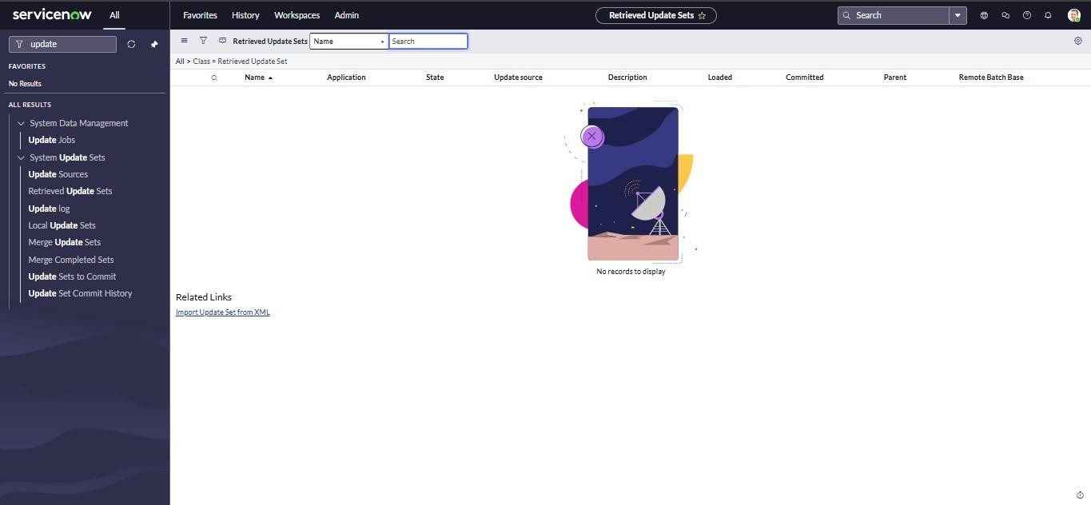

 

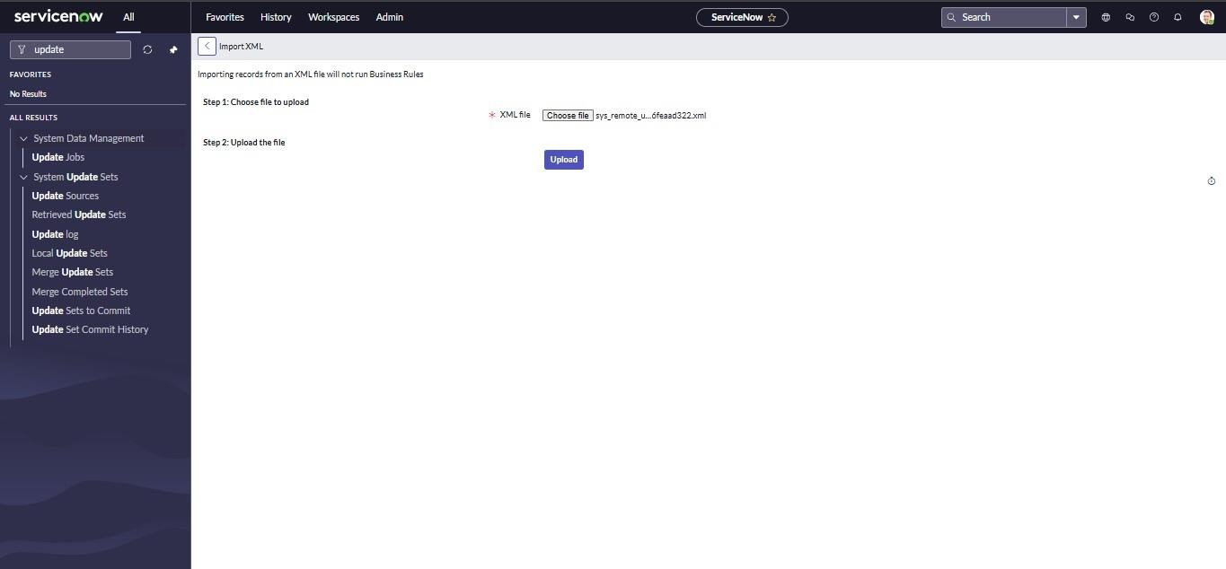

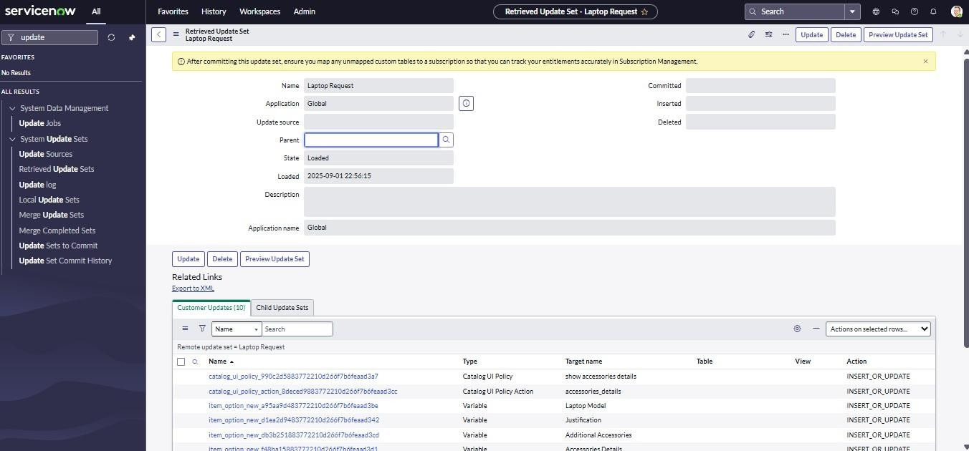

 

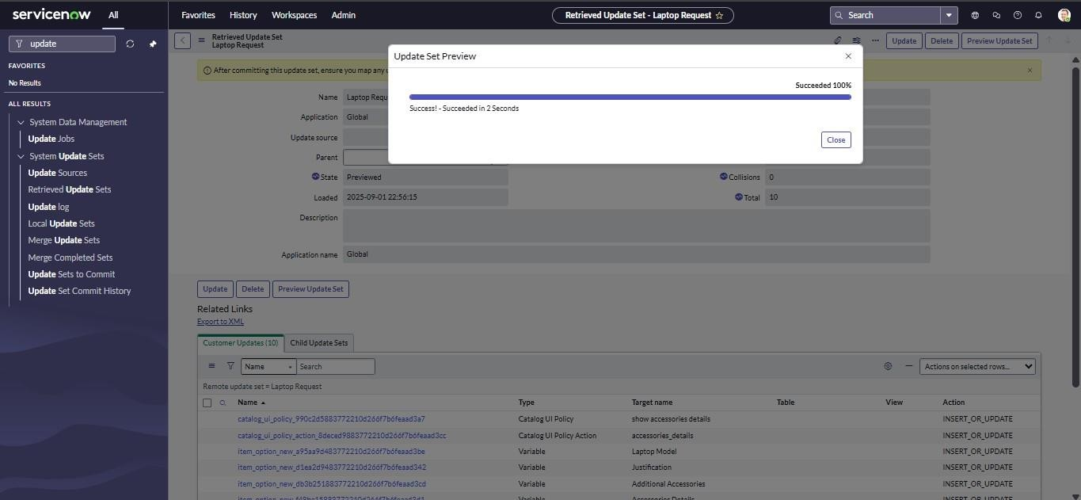

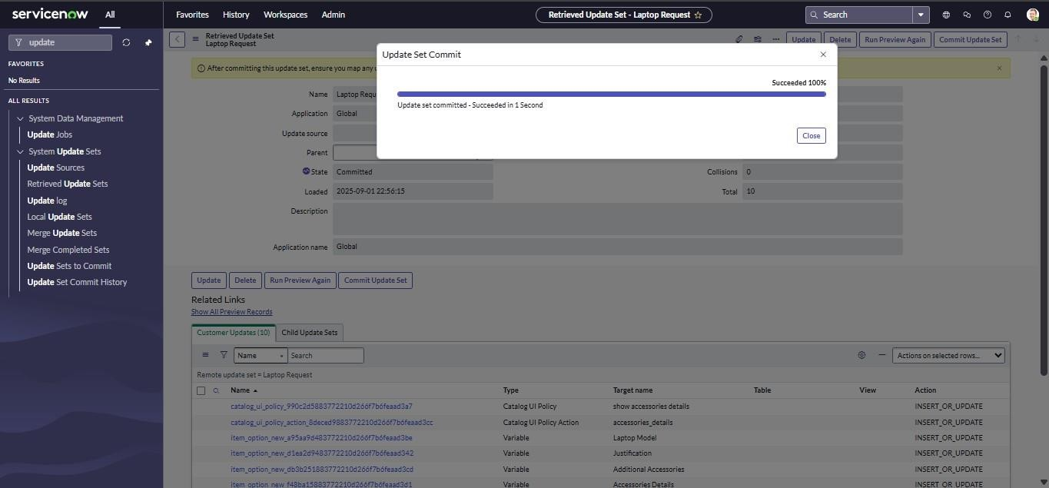

 

## Step 7: Test the Catalog Item

Submit a test request and verify:  Workflow triggers

 Form behavior

 Request visibility in ServiceNow portal

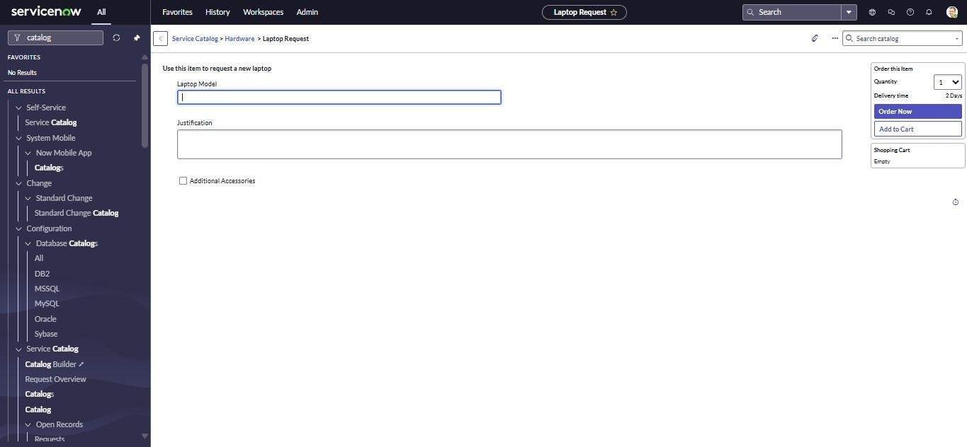

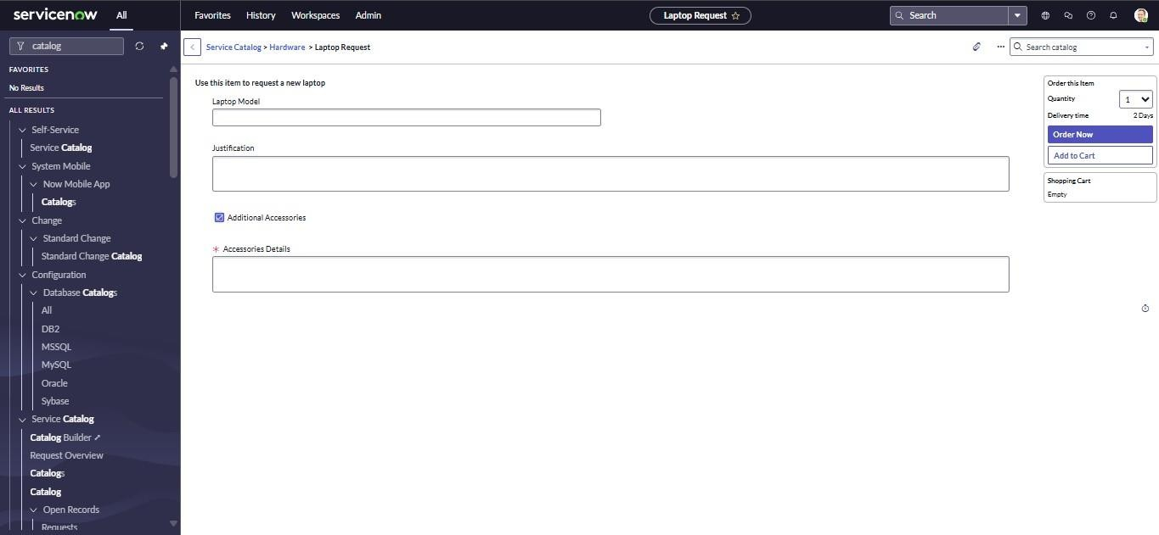

 

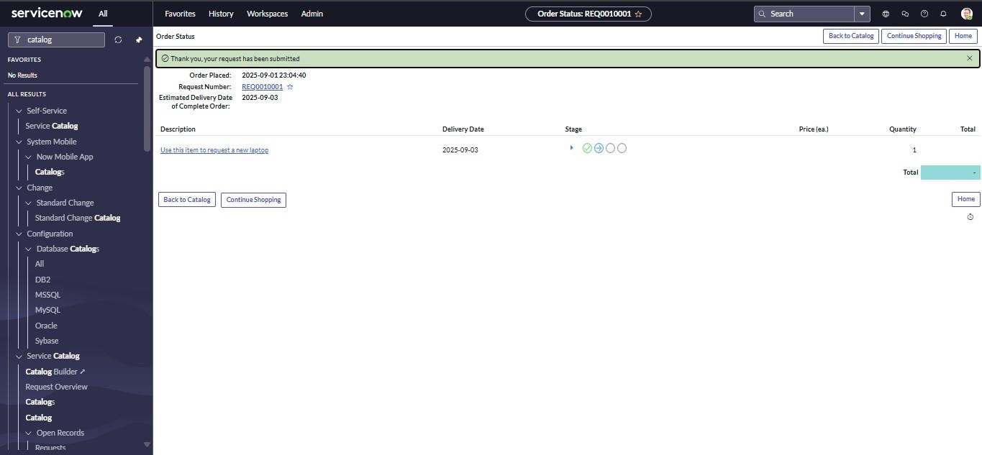

# Conclusion

The *Laptop Request Catalog Item* project successfully automated the laptop request process within an organization using the ServiceNow platform. By replacing traditional manual methods with a structured digital workflow, the solution significantly improved efficiency, accuracy, and user satisfaction.

Through the use of Service Catalog, UI Policies, UI Actions, and Workflow Automation, the project delivered a dynamic and interactive form that simplifies the request and approval process. Employees can now easily submit requests, while IT administrators can track, approve, and fulfill them with complete transparency. The inclusion of features such as dynamic fields, form reset functionality, and update set management ensures smooth operation and easy deployment across multiple instances.

Overall, the project demonstrates the power of ServiceNow in automating routine IT service management tasks, reducing human errors, and enhancing overall productivity and governance within the organization.

 

# Future Scope

While the current implementation effectively automates laptop requests, there are several potential enhancements that can further extend its functionality:

## Integration with Asset Management:

Connect the catalog item with the organization’s asset database to automatically track issued laptops and update inventory records.

## Approval Hierarchy Customization:

Enable multi-level approval workflows based on employee designation or department.

## Automated Notifications and Reminders:

Add scheduled reminders and follow-up notifications for pending approvals or delayed requests.

## Reporting and Analytics:

Develop dashboards to analyze request trends, processing times, and resource allocation for better decision-making.

## Mobile Accessibility:

Optimize the catalog form for mobile devices through the ServiceNow mobile app, allowing users to submit requests on the go.

## Expansion to Other Assets:

Extend the same framework to manage other IT assets such as monitors, accessories, and software licenses.

These enhancements will make the system more comprehensive, intelligent, and aligned with evolving organizational IT service management needs.